**FACE DETECTION APP ON AWS**

**INTRODUCTION**

Amazon Web Services (AWS) is the world's most comprehensive and broadly adopted cloud platform, offering over 175 fully featured services from data centers globally. Amazon Web Services offers reliable, scalable, and inexpensive cloud computing services. Free to join, pay only for what you use.

Facial recognition and comparison is a new challenge you will face if you are developing an employee verification system, need to automate video editing, or provide secondary authentication for other applications. To solve this challenge, you could develop your own machine learning model, develop an API, and manage your own infrastructure. This option is expensive, requires advanced knowledge, and is time intensive.

Instead of taking the difficult route, you can use Amazon Rekognition, which can detect faces in an image or video, find facial landmarks such as the position of eyes, and detect emotions such as happy or sad in near real-time or in batches without management of infrastructure or modeling.

Here I’m using few of the amazon web services (ec2, s3, Rekognition) and telegram as a front end to build face-detection app.

**ARCHITECTURE S3**

2

** Telegram EC2**

5

4

3

6

1

**Rekognition**

**COMPONENTS**

1. Ec2

Amazon Elastic Compute Cloud (Amazon EC2) provides scalable computing capacity in the Amazon Web Services (AWS) cloud. Using Amazon EC2 eliminates your need to invest in hardware up front, so you can develop and deploy applications faster. You can use Amazon EC2 to launch as many or as few virtual servers as you need, configure security and networking, and manage storage. Amazon EC2 enables you to scale up or down to handle changes in requirements or spikes in popularity, reducing your need to forecast traffic.

1. S3

Amazon Simple Storage Service (Amazon S3) is an object storage service that offers industry-leading scalability, data availability, security, and performance. This means customers of all sizes and industries can use it to store and protect any amount of data for a range of use cases, such as websites, mobile applications, backup and restore, archive, enterprise applications, IoT devices, and big data analytics

1. Amazon Rekognition

Amazon Rekognition makes it easy to add image and video analysis to your applications. You just provide an image or video to the Amazon Rekognition API, and the service can identify objects, people, text, scenes, and activities. It can detect any inappropriate content as well. Amazon Rekognition also provides highly accurate facial analysis, face comparison, and face search capabilities

1. Telegram Bot

Bots are third-party applications that run inside Telegram. Users can interact with bots by sending them messages, commands and [inline requests](https://core.telegram.org/bots#inline-mode). You control your bots using HTTPS requests to our [Bot API](https://core.telegram.org/bots/api).

**REQUIREMENTS ANALYSIS**

The requirement analysis specifies the requirements needed to develop a graphic project. In this phase, we collect the requirements needed for designing the project. The requirements collected are then analyzed and carried to the next phase.

**1. SOFTWARE REQUIREMENTS:**

1. PutTTYgen
2. PuTTY

**2. HARDWARE REQUIREMENTS:**

1. Operating System: Amazon Linux 2
2. Ram: 1GB ram
3. Processor: 1 virtual CPU
4. Storage: 8GB

**PROCEDURE:**

1. Create a telegram bot

* Install and open telegram
* Search for BotFather in the search bar and open it
* Type /newbot, once you type it will ask to type the name of the bot, type the name of the bot and hit enter
* After that it will ask to choose the user name for your bot, type the username for the bot and hit enter
* Your new bot is ready now

1. In order to use the amazon web services, we need create a amazon web service(AWS) account.

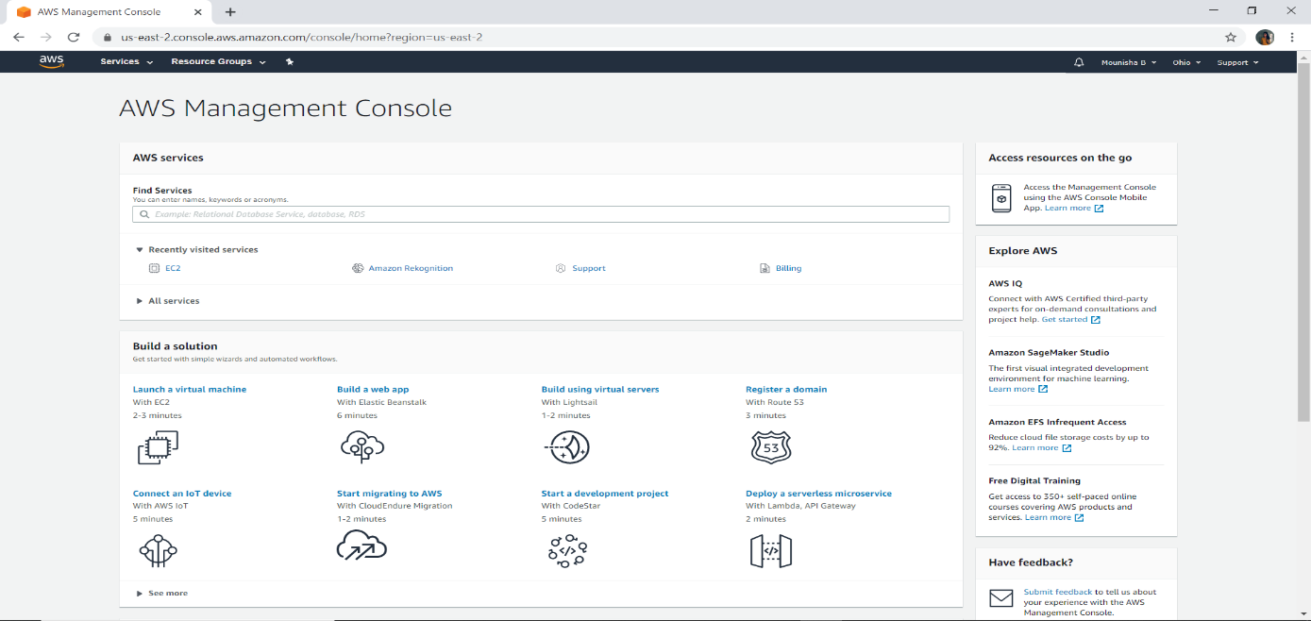

Snapshot 1

1. After successfully creation of AWS account, launch an instance (i.e., create an server).

Go to services and select EC2

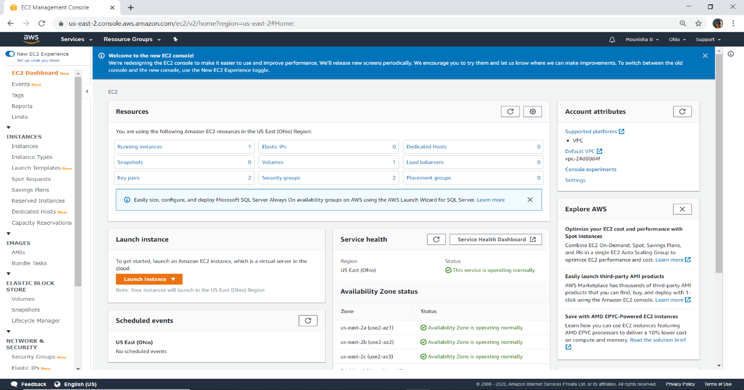

Snapshot 2

1. Choose an Amazon Machine Image (AMI)

Here I have selected Amazon Linux 2

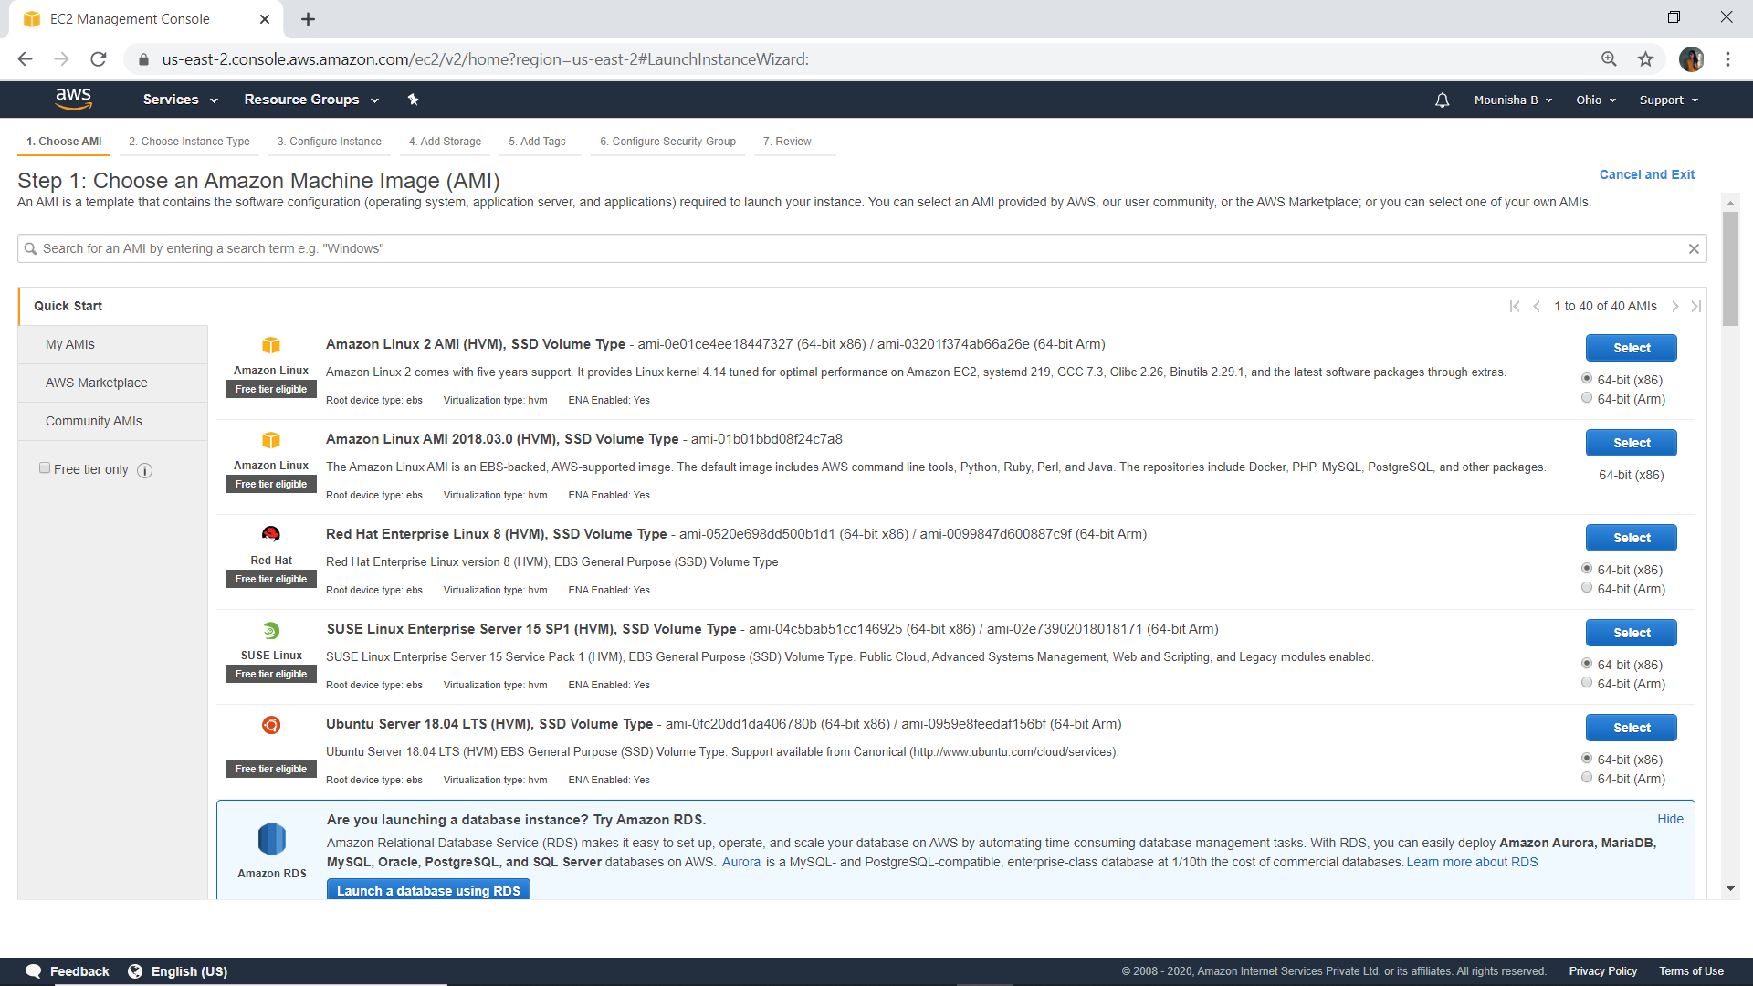

Snapshot 3

1. Choose instance type

Here I have selected t2 micro so that I will get 1 CPU and 1 GB ram

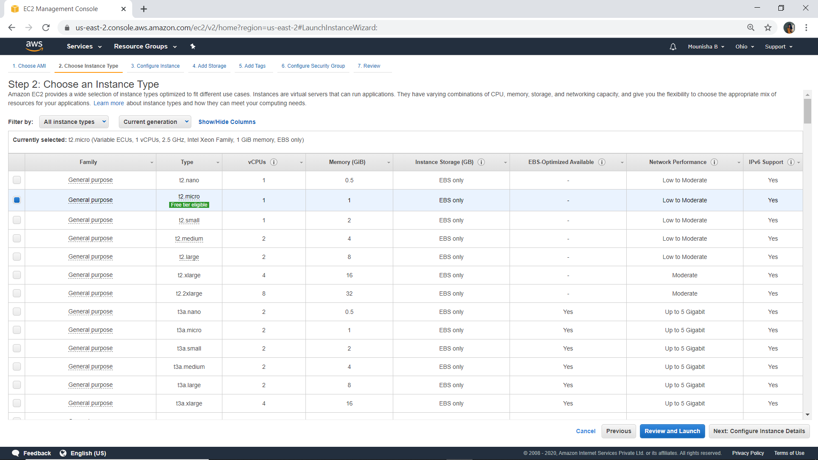

Snapshot 4

1. Configure instance

Here I left as it is without changing anything (click next)

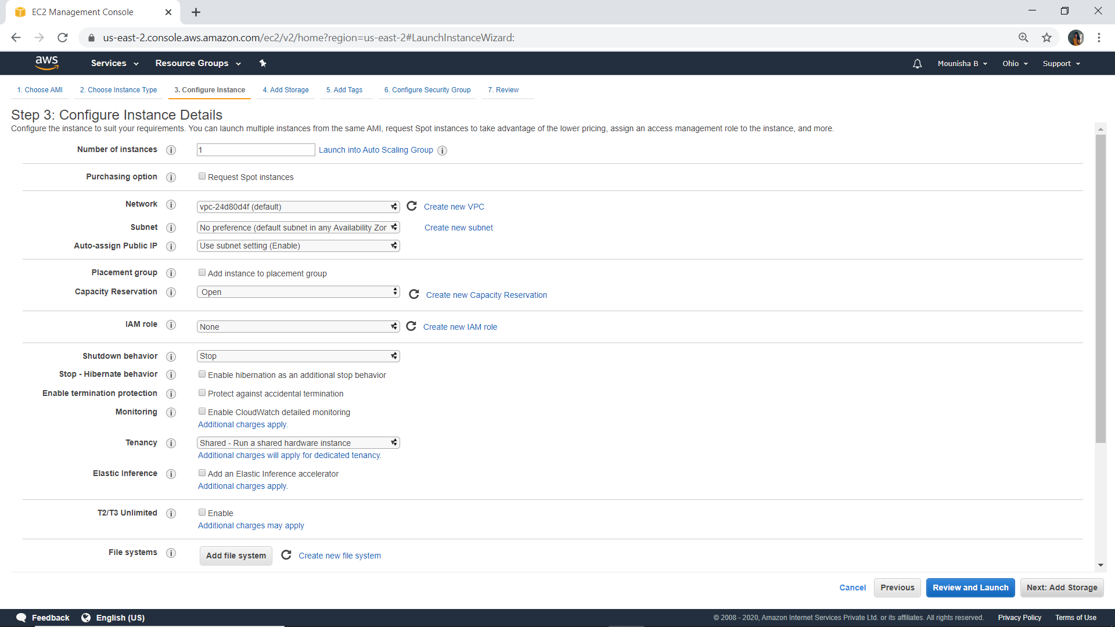

Snapshot 5

1. Add storage

By default they have given 8GB so that is enough to build the project (click next)

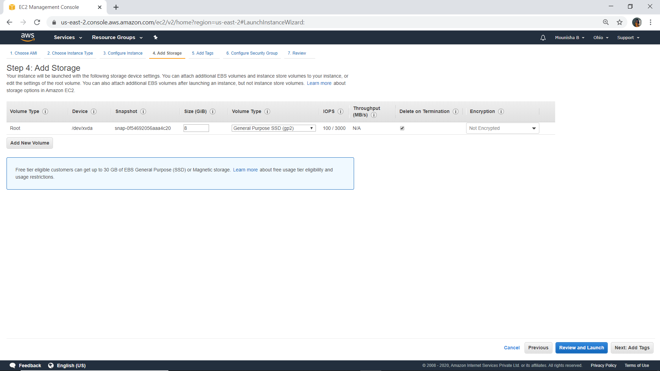

Snapshot 6

1. Add tags

Leave as it is without changing anything in this section (click next)

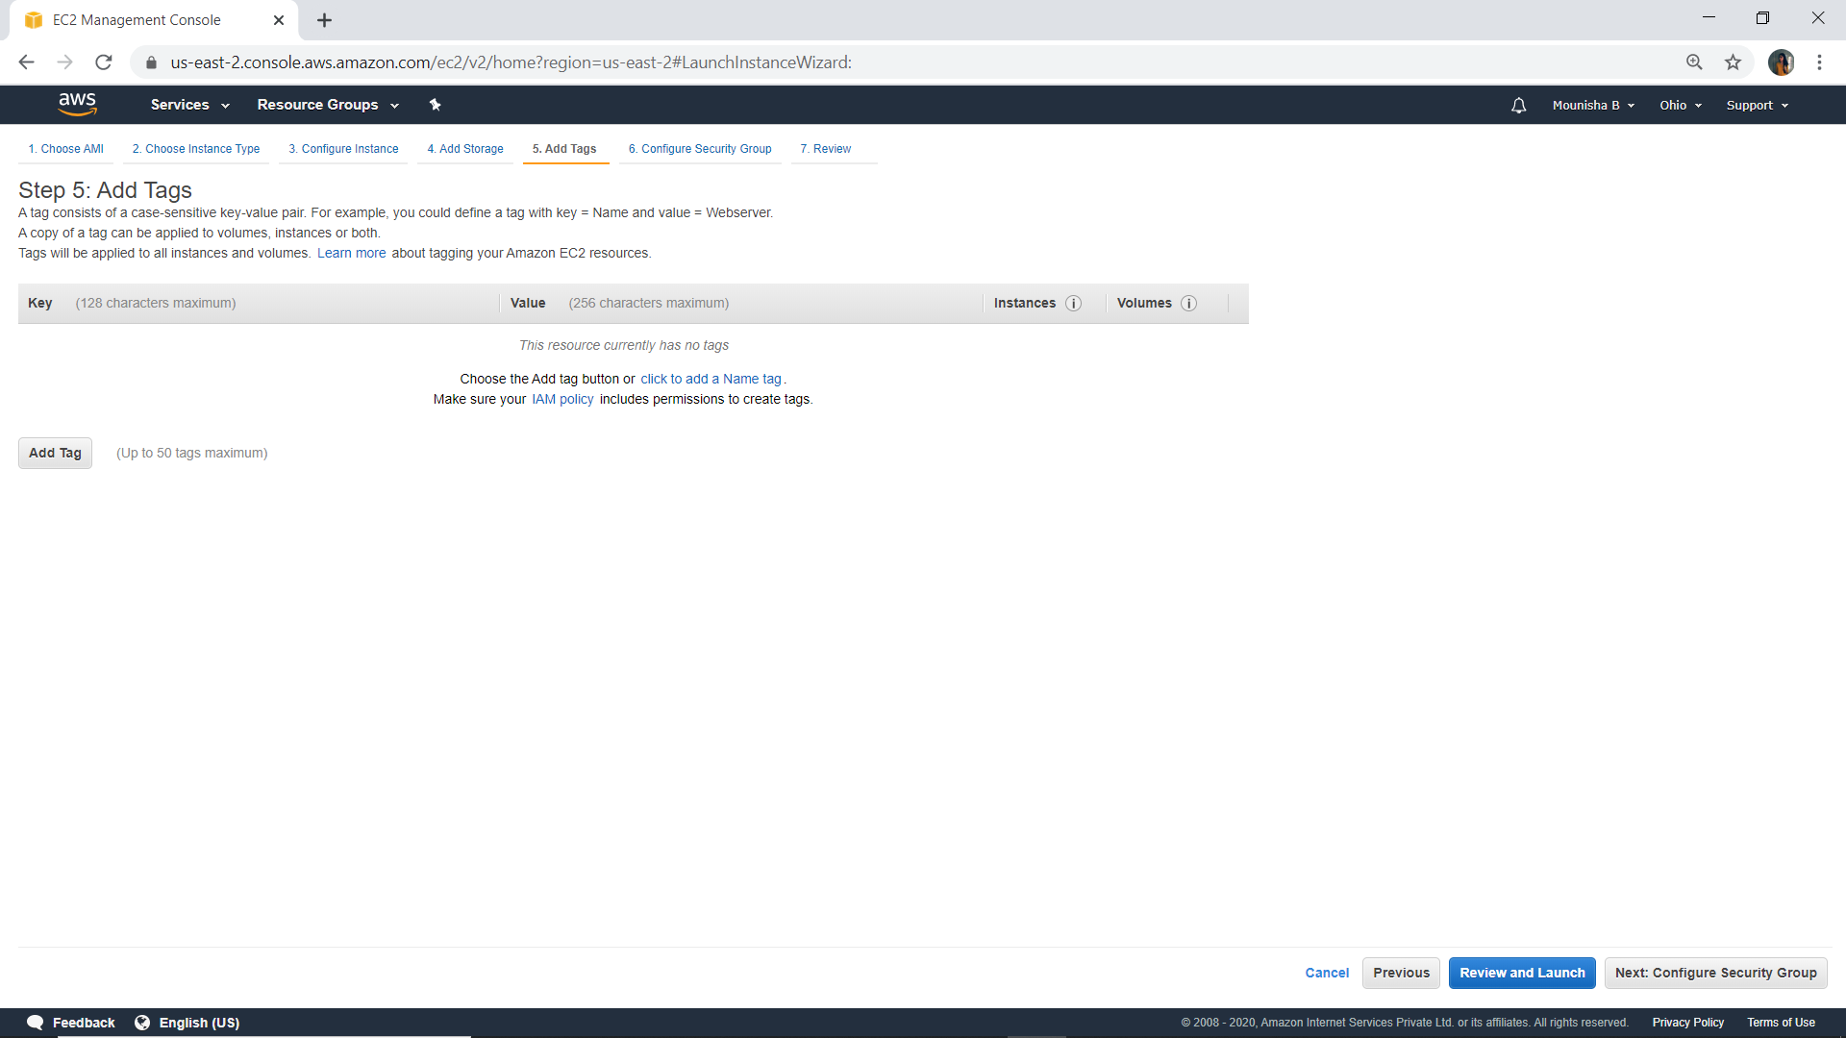

Snapshot 7

1. Configure security group

Select type: SSH and port range: 22 (click on review and launch)

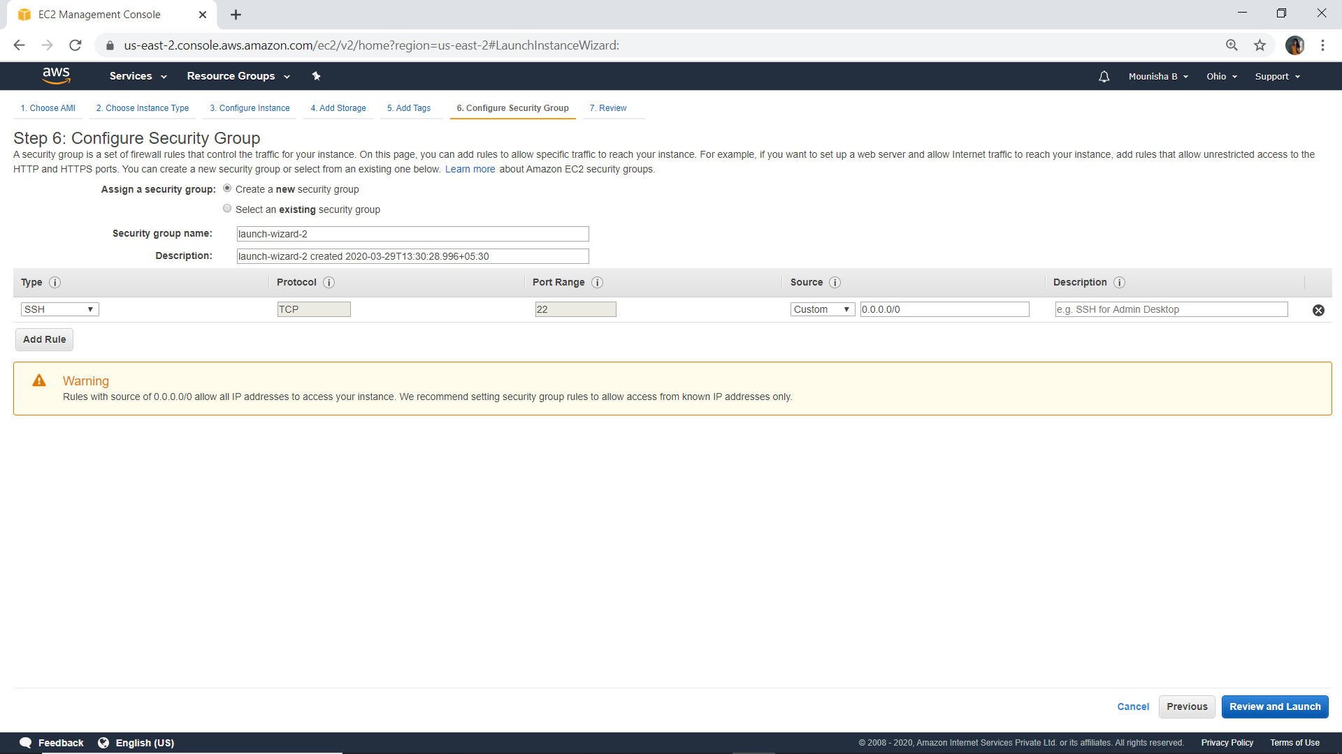

Snapshot 8

1. Review

Reviewing what I have selected in the previous steps (click on launch)

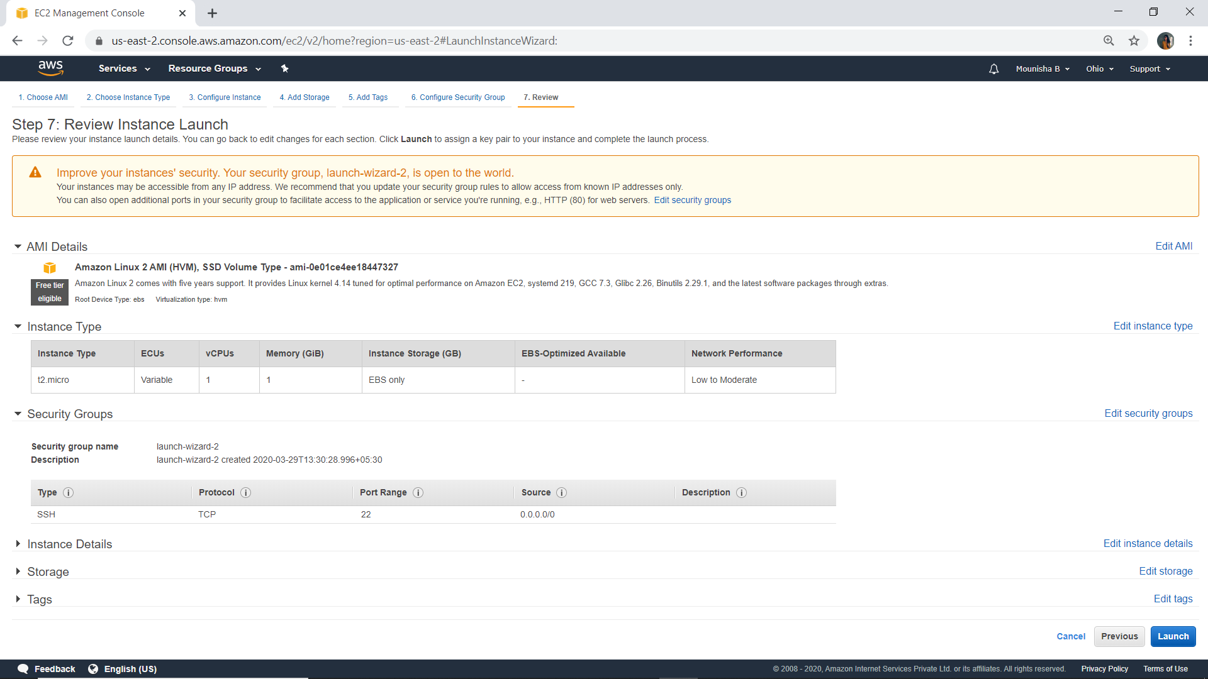

Snapshot 9

1. Select an existing key pair or select a new key pair

Select on new key pair and give a name to it and download the key pair

The extension of the a downloaded key pair will be .pem

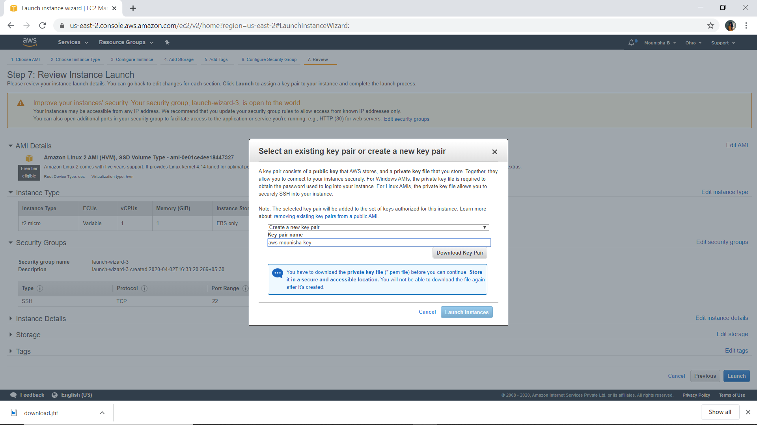

Snapshot 10

1. Launch log

So I have launched a machine which is residing in us east(Ohio)

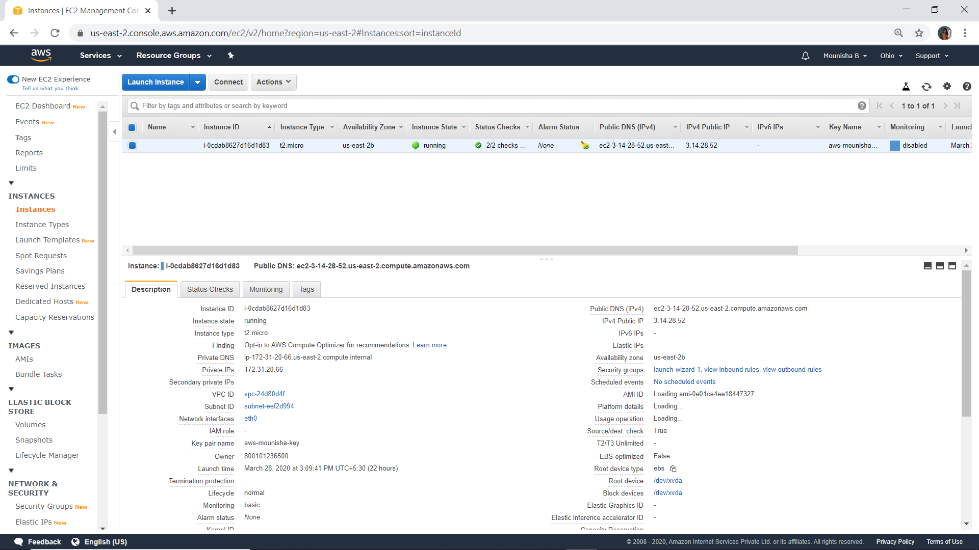

Snapshot 11

1. How do we connect?

This particular instance is a Linux based instance. For connecting to linux based instance we have a software called PuTTY

1. Download putty and Connect AWS machine using putty
2. AWS Linux operating system basically follows key pairs

There are two types of keys

1. Public key: they are stored on the server/instance
2. Private key: they are the one we have to upload while connecting to the server

Putty accepts the private key in the form of ppk but we have downloaded a private key from AWS which is in the form of pem, so there is a mismatch in the file extensions

Now we have to convert .pem -> .ppk using PuTTYgen

* Open the software PuTTYgen
* Load the .pem file into PuTTYgen so that it will convert .pem file into .ppk file

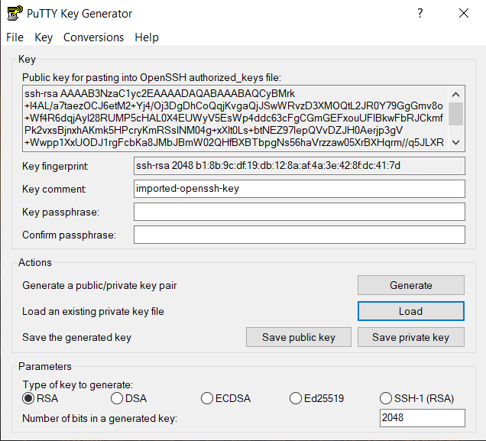

Snapshot 12

1. Use the software PuTTY and get connected

* Open the software PuTTY
* Make sure that the connection type is SSH and port number is 22 and

Enter the IP address

* Go to SSH on the LHS and open it
* Go to auth within SSH and select it
* Click on browse and select the converted ppk file (click open)

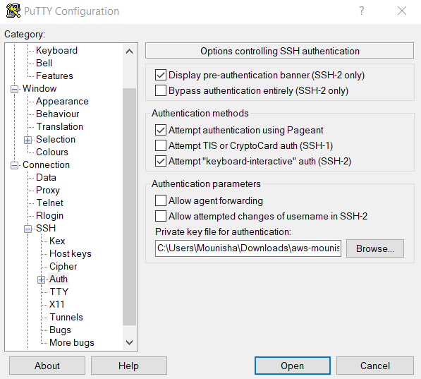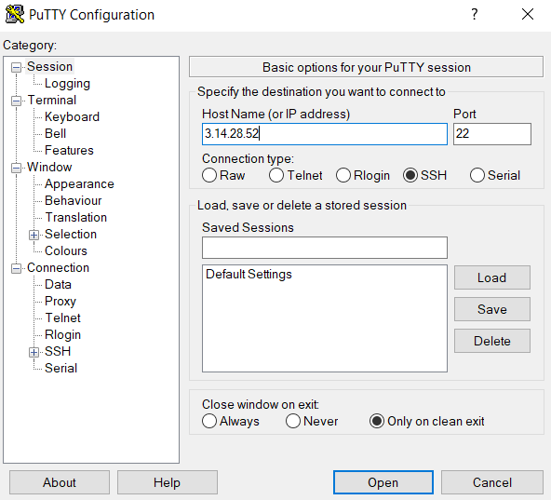

Snapshot 13 Snapshot 14

1. Putty console will be displayed and you will be prompted to enter the user the name

* 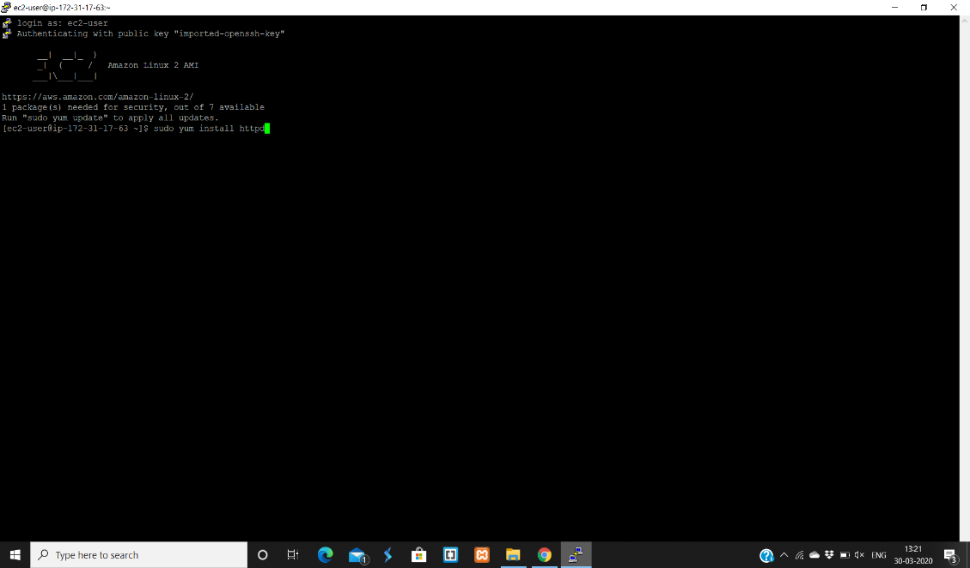Username for this machine is ec2-user, we don’t need to enter password because we have private key

Snapshot 15

* After successful login, install apache(httpd) server using command

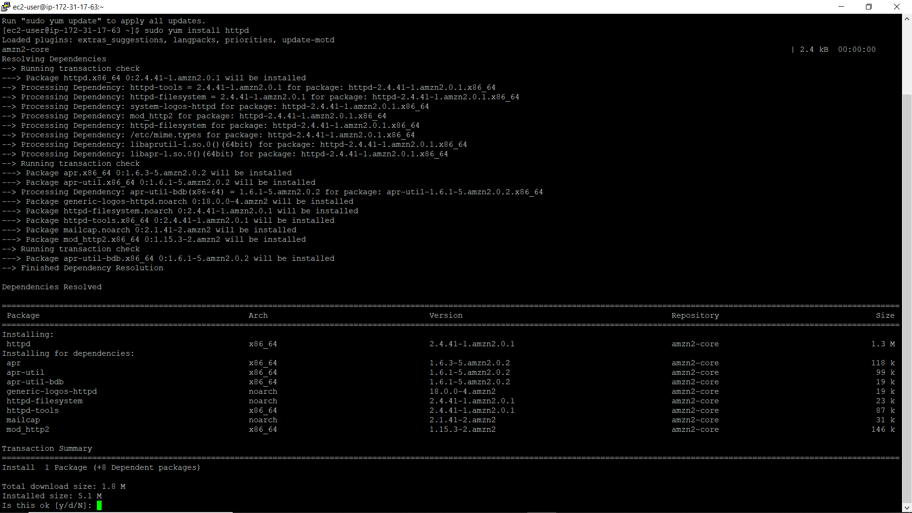 sudo yum install httpd and type y to install.

Snapshot 16

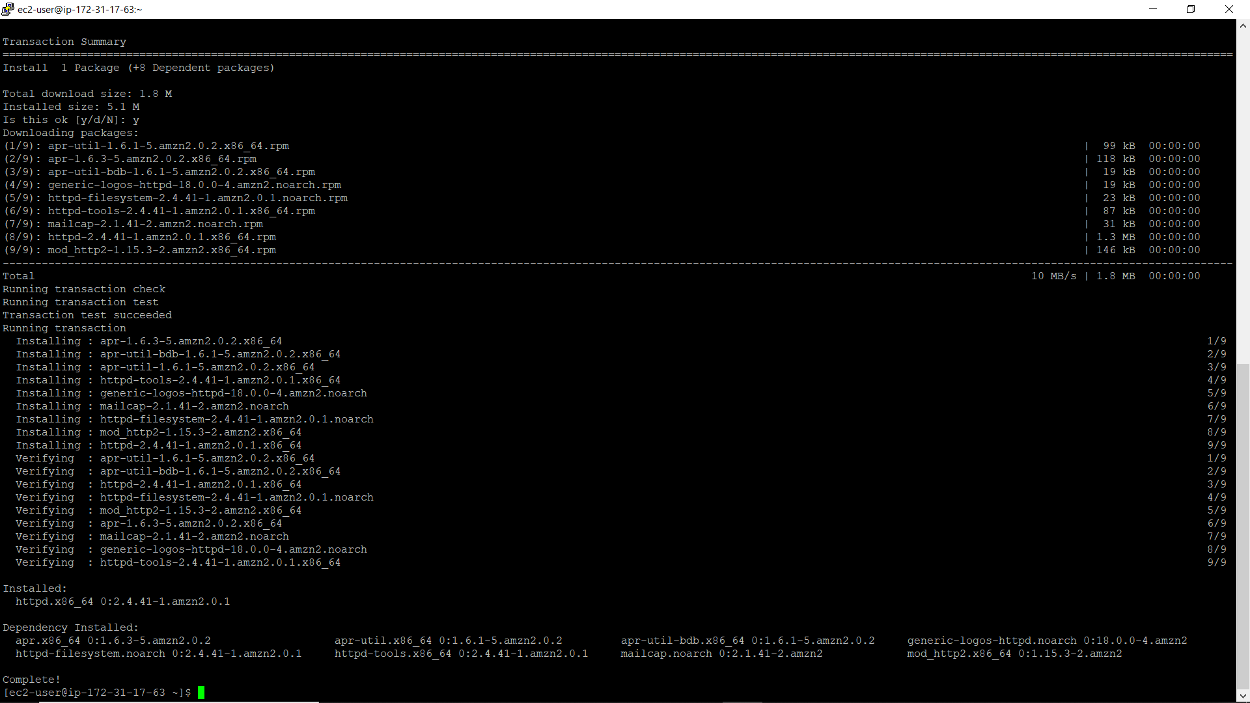

Snapshot 17

* After installing the server, start the service by using the command

sudo service httpd start

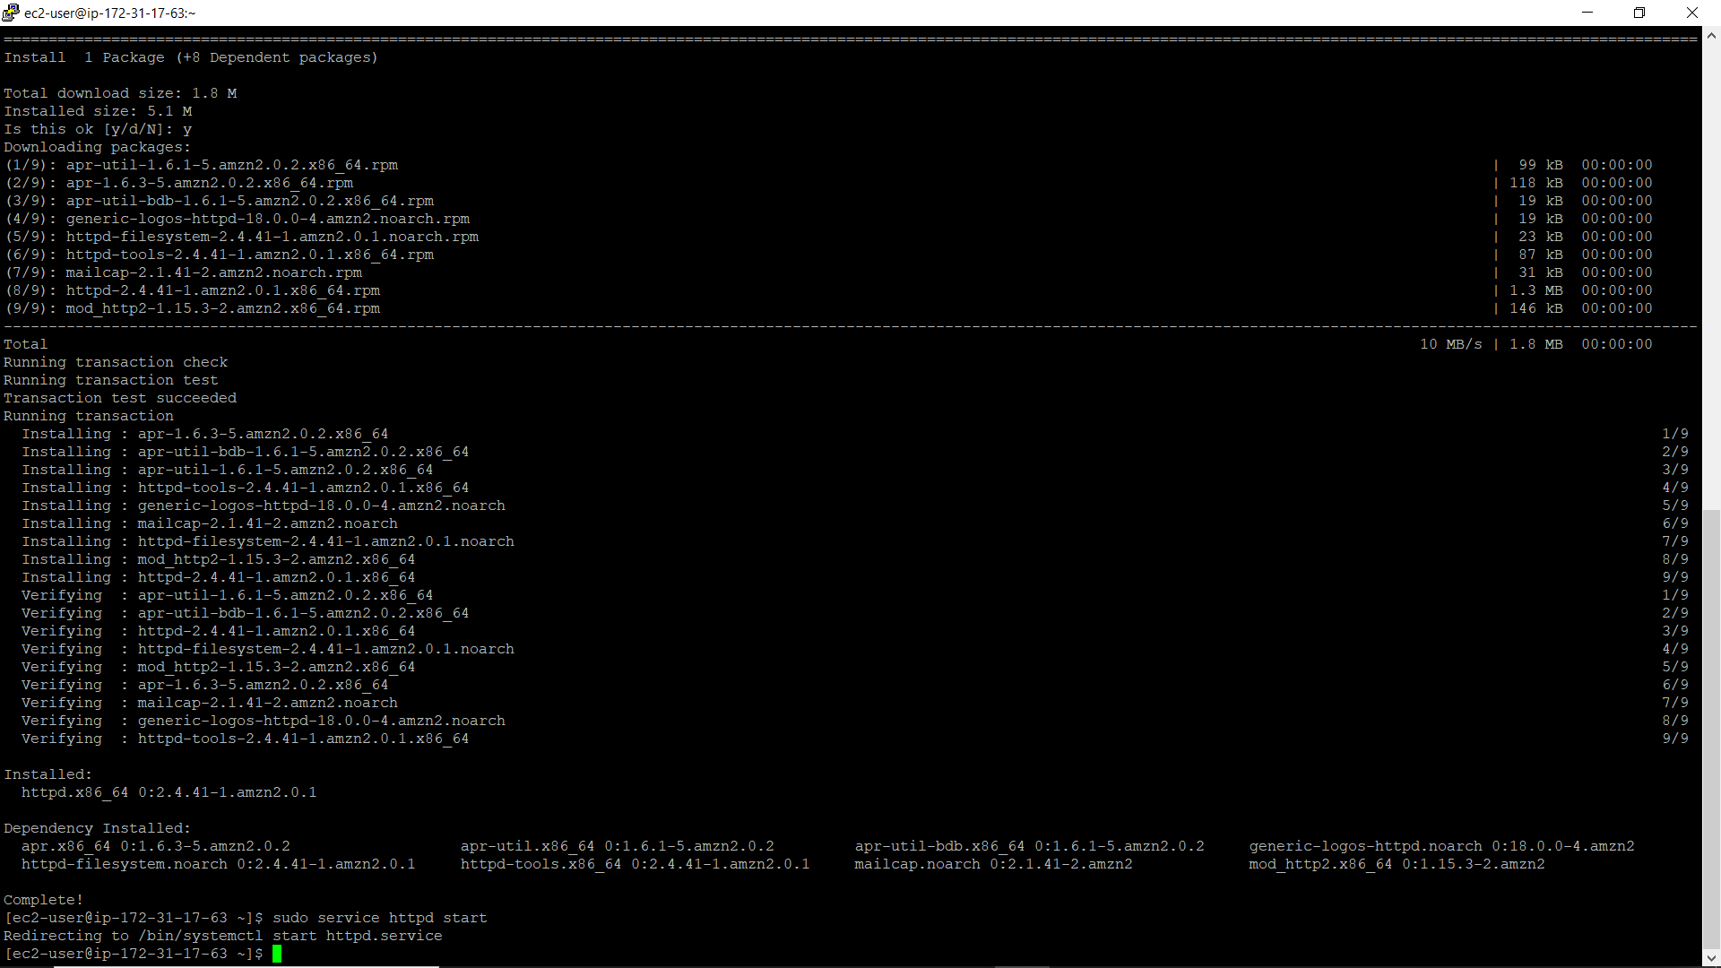

Snapshot 18

* Type sudo service httpd status to check whether the service has been started or not

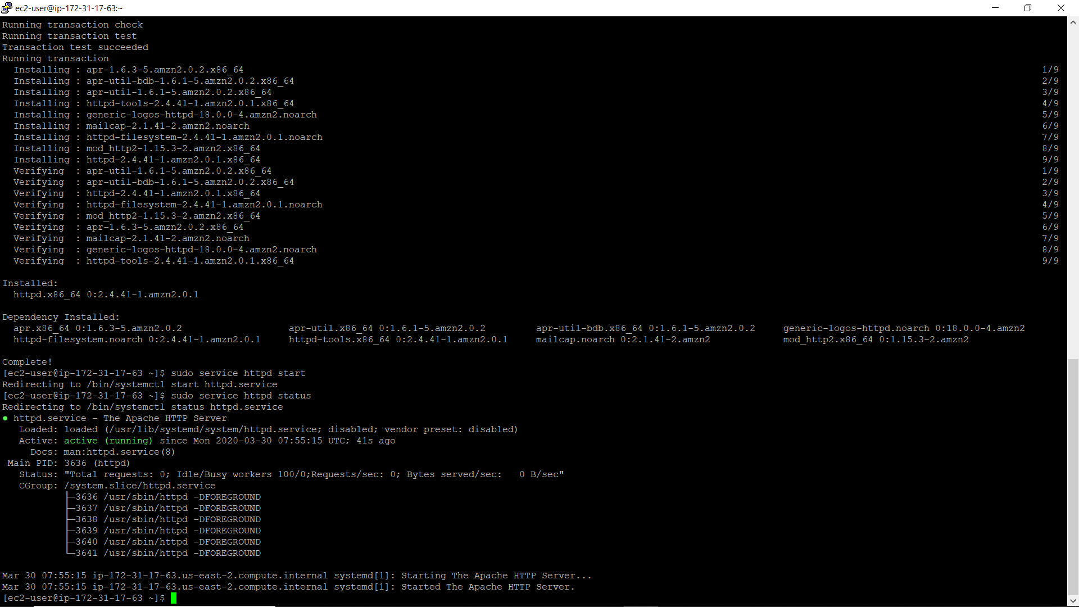

Snapshot 19

* Type sudo vim /var/www/html/index.html (hit enter and press I)

Type whatever you want in the black screen and press esc :wq to save and exit 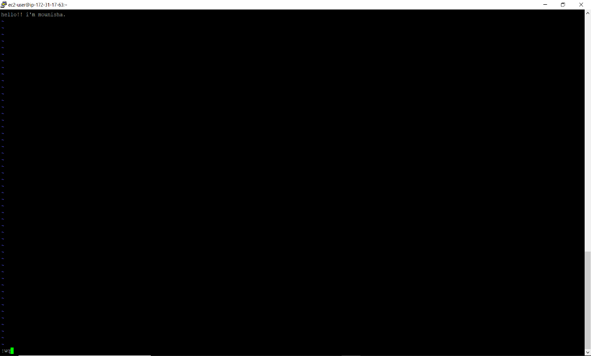

Snapshot 20

* Go back to AWS ec2 instance and copy the ip address and paste it on the browser, it keeps buffering because we have opened a port number 22 while we are launching an instance this means that it only allows SSH traffic and denies all the other traffic.

So, what we need to do is go to security groups and click on launch wizard-2 and click on security group and click on edit inbound rules and add http and save the rules.

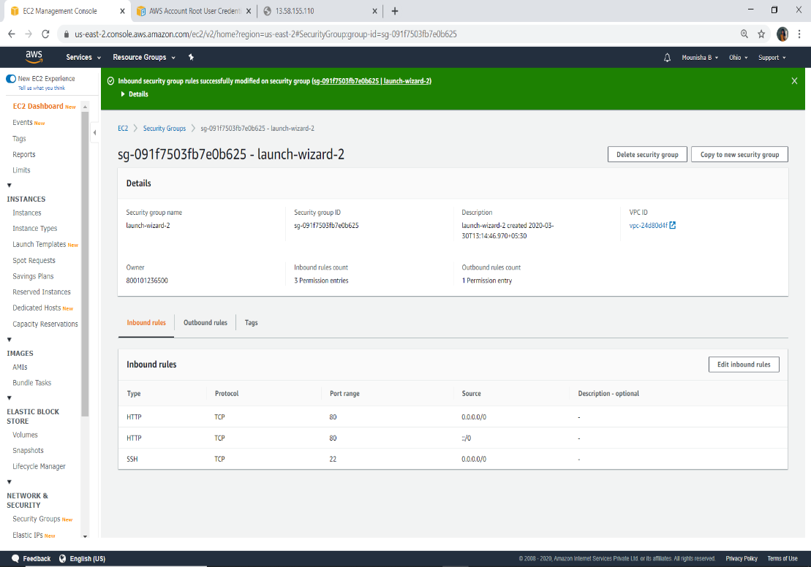

Snapshot 21

After adding http, go to browser and refresh the page so that you will get what you have typed.

1. Create an s3(simple storage service) bucket

It is a storage for the internet provided by AWS and it is designed to make web-scale computing easy.

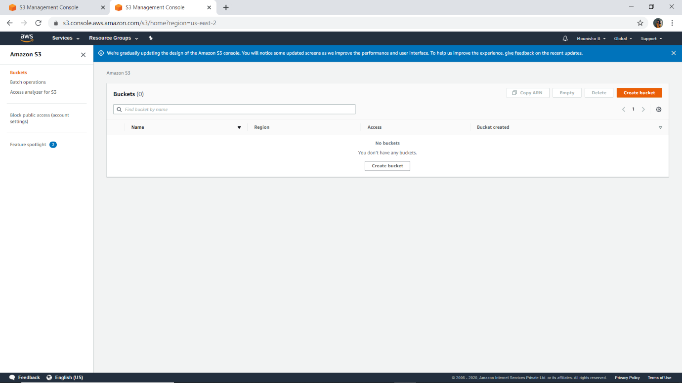

Snapshot 22

1. Create a bucket

* Click on create bucket

Enter the bucket name and select the region and click on create bucket

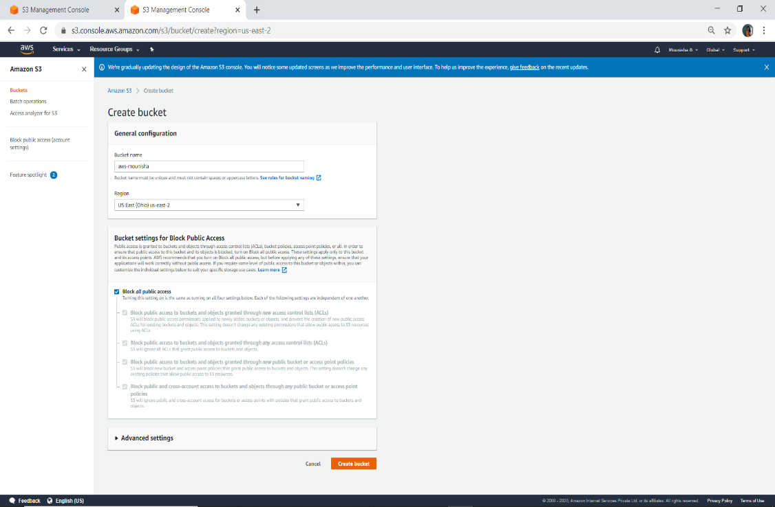

Snapshot 23

* After creating the bucket, the details of your bucket will appear on your s3 console

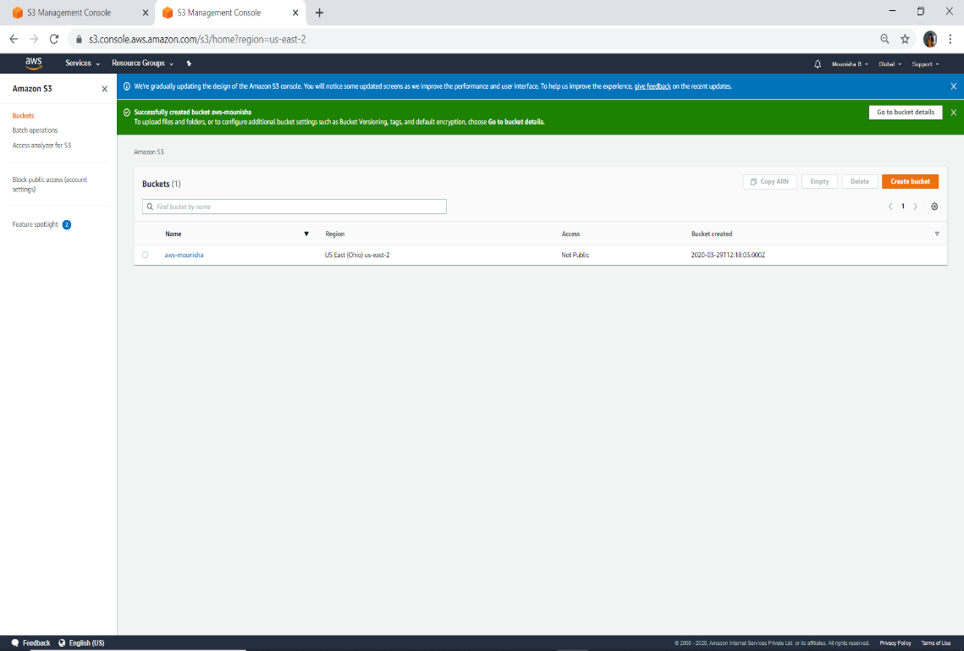

Snapshot 24

* Things present inside the s3 bucket

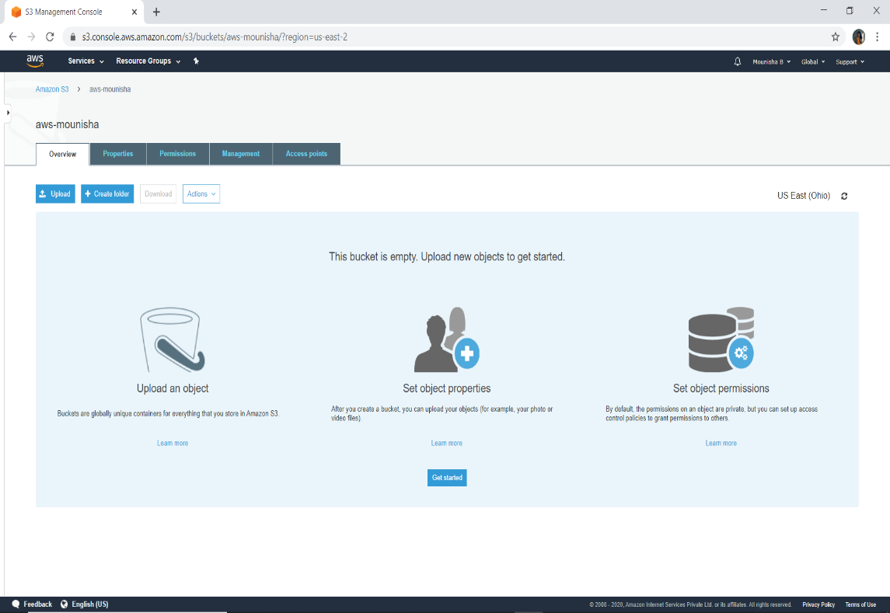

Snapshot 25

1. Uploading objects into the bucket

* Select files:

Click on upload and add the files which you want to upload into the bucket(click next)

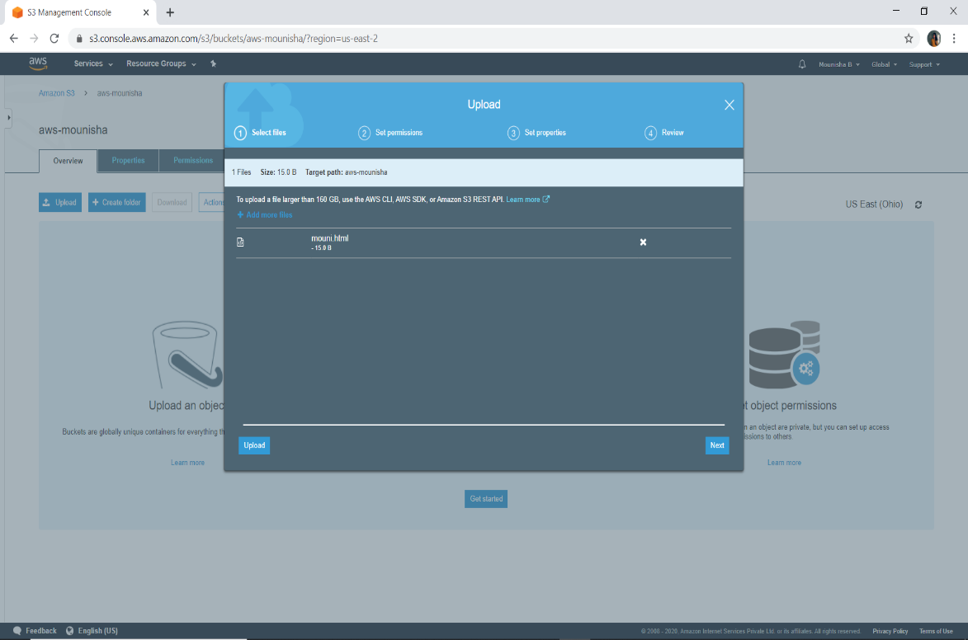

Snapshot 26

* Set permissions: without changing anything click next

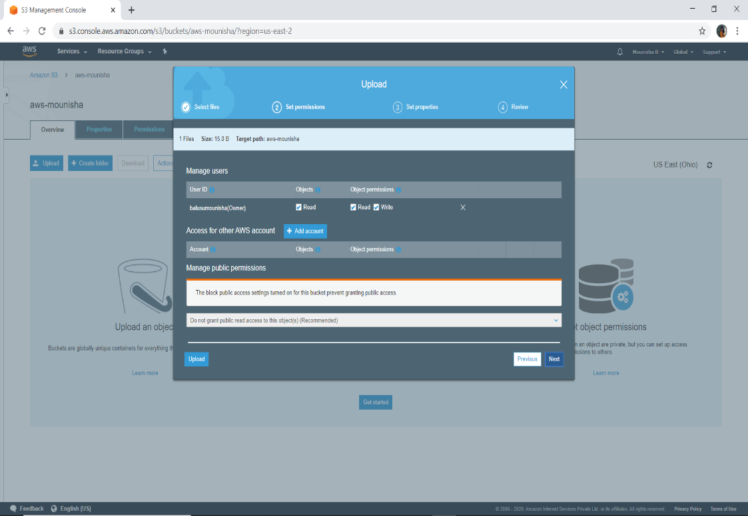

Snapshot 27

* Set properties: select standard and click on next

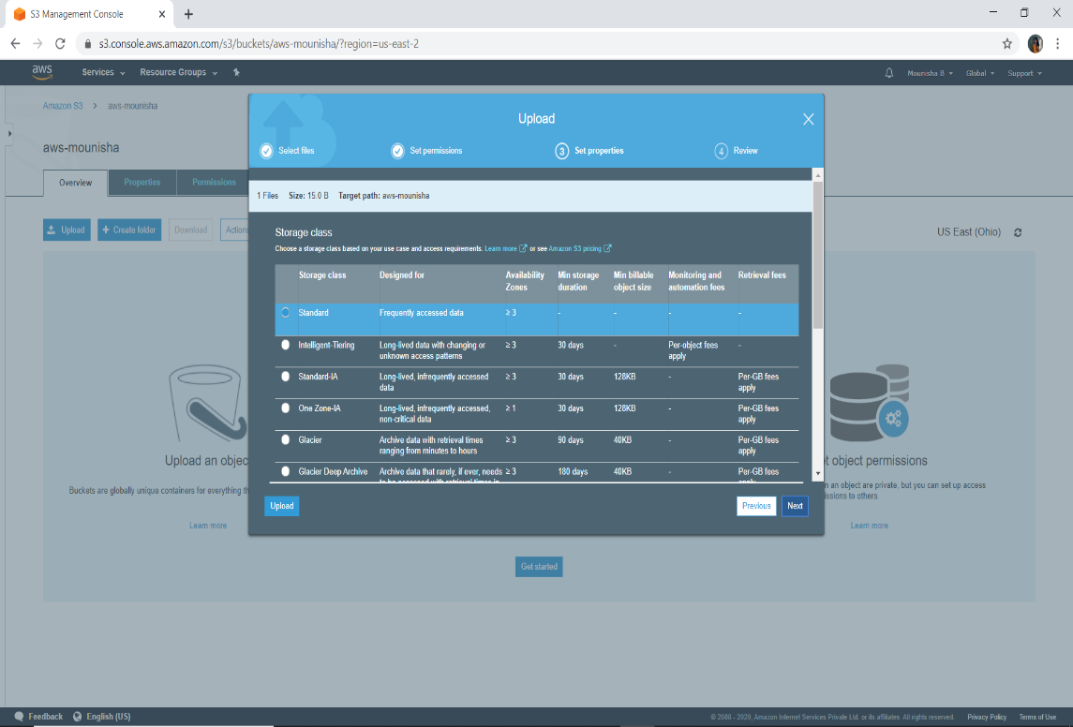

Snapshot 28

* Review: click on upload

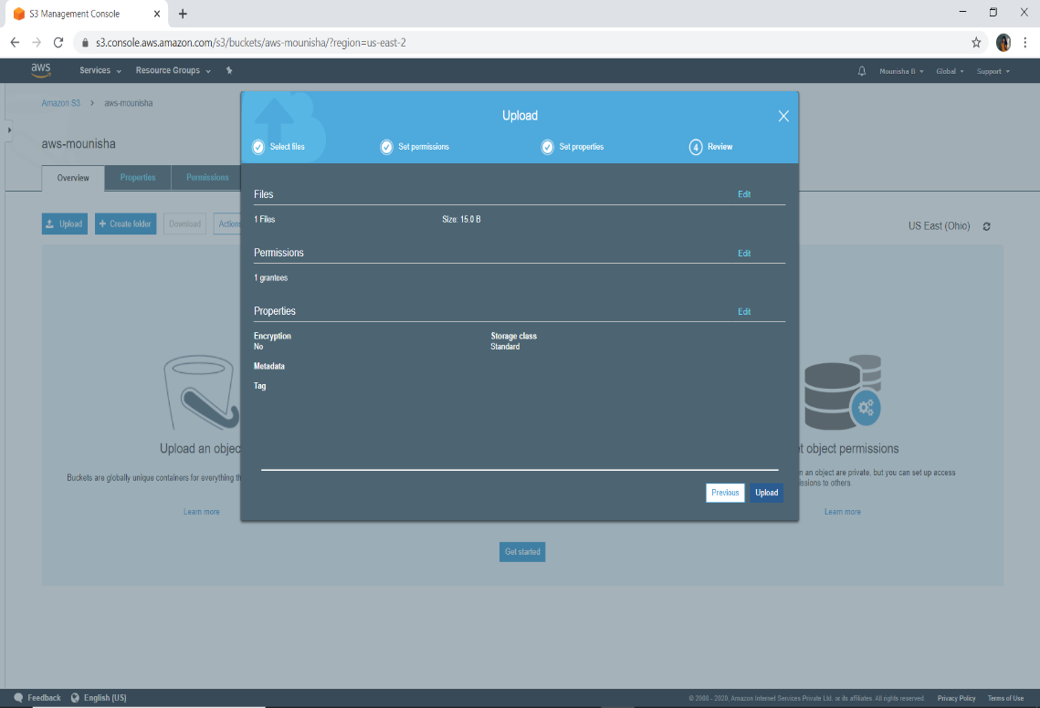

Snapshot 29

* After couple of seconds the file will be uploaded

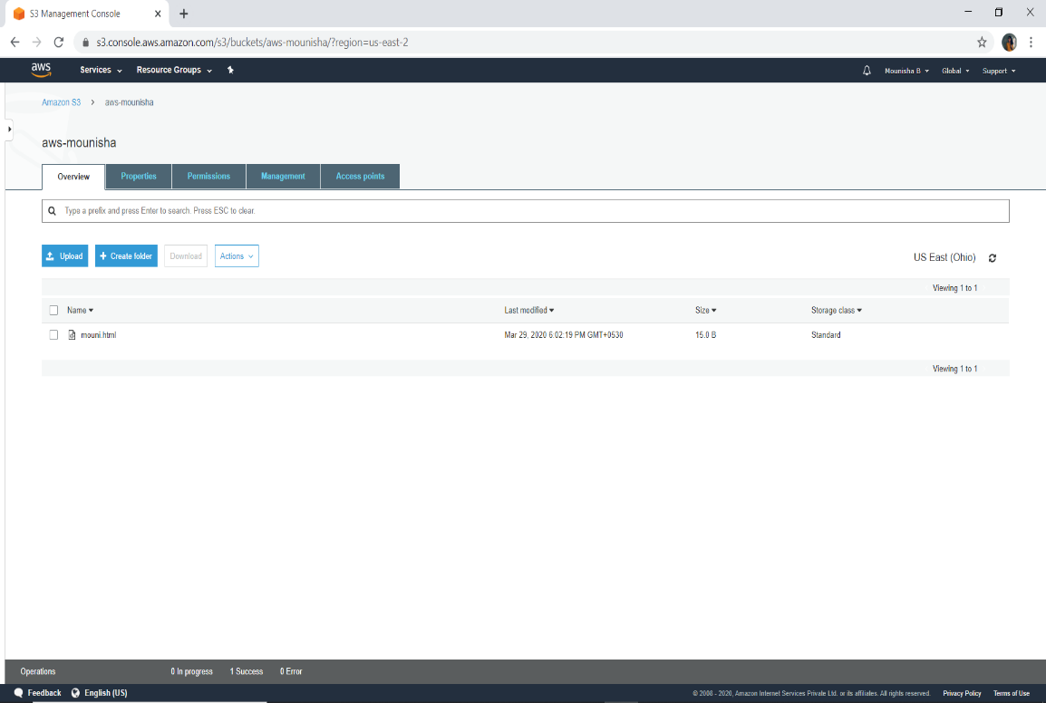

Snapshot 30

1. Static web hosting

Click on object and click on the object URL

If we click on the URL the output will not be displayed it will show some error like access denied

In order to access it we need to make some configurations.

* We can download the object by clicking on download button and view the file

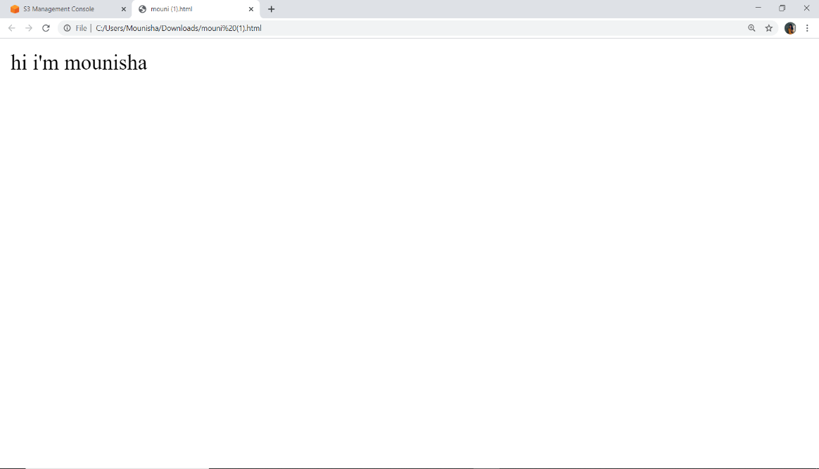

snapshot 31

* 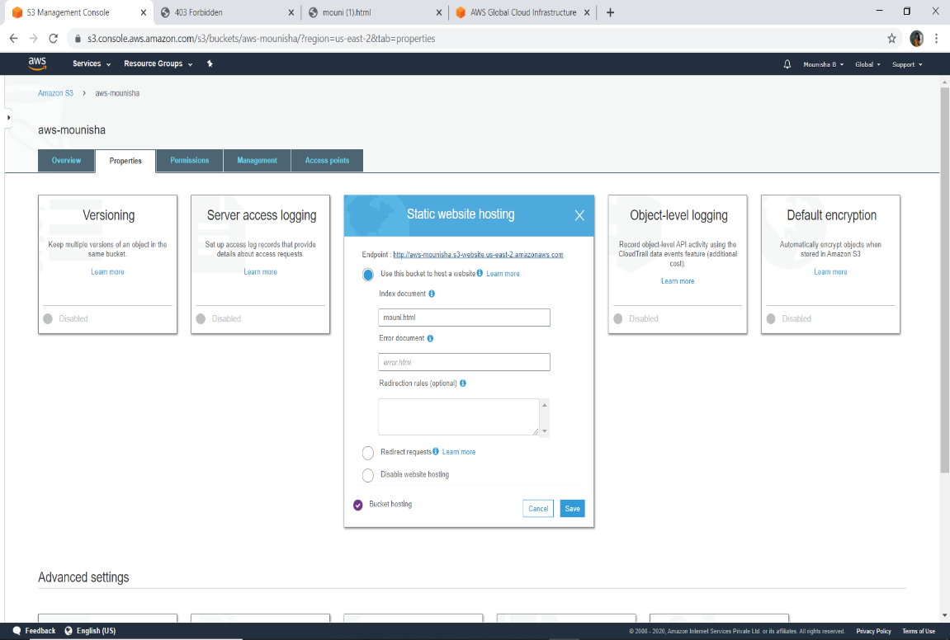In order to make it as webhosted, click on properties and click on static webhosting and select use this bucket to host a website enter the object name and click on save

Snapshot 32

Again click on static website hosting, you will find a end point click on that and you will get a error like forbidden access that is because we have not enabled public access to this bucket

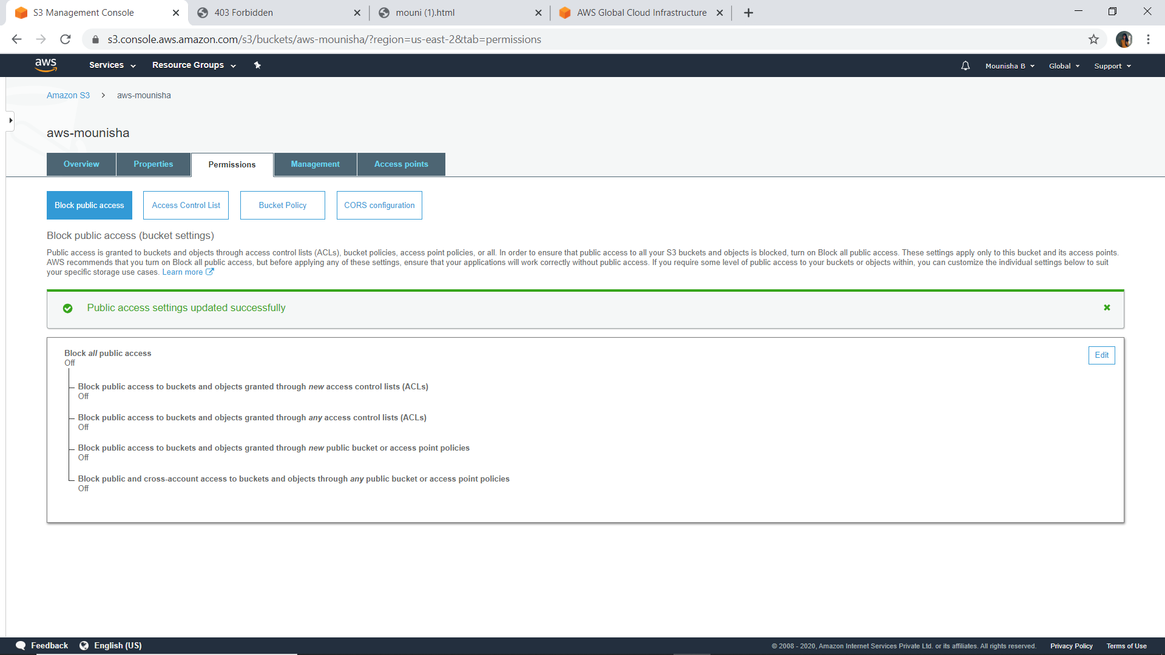So go to permissions, click on edit and switch off the block all public access and type in confirm.

Snapshot 33

Again it will give an error because both and bucket and object has to be public so go back and click on object click on make public.

1. Uploading objects from ec2 to s3
2. Login to putty using ip address and private key

* Install php using the below command

sudo yum install php and type y for all

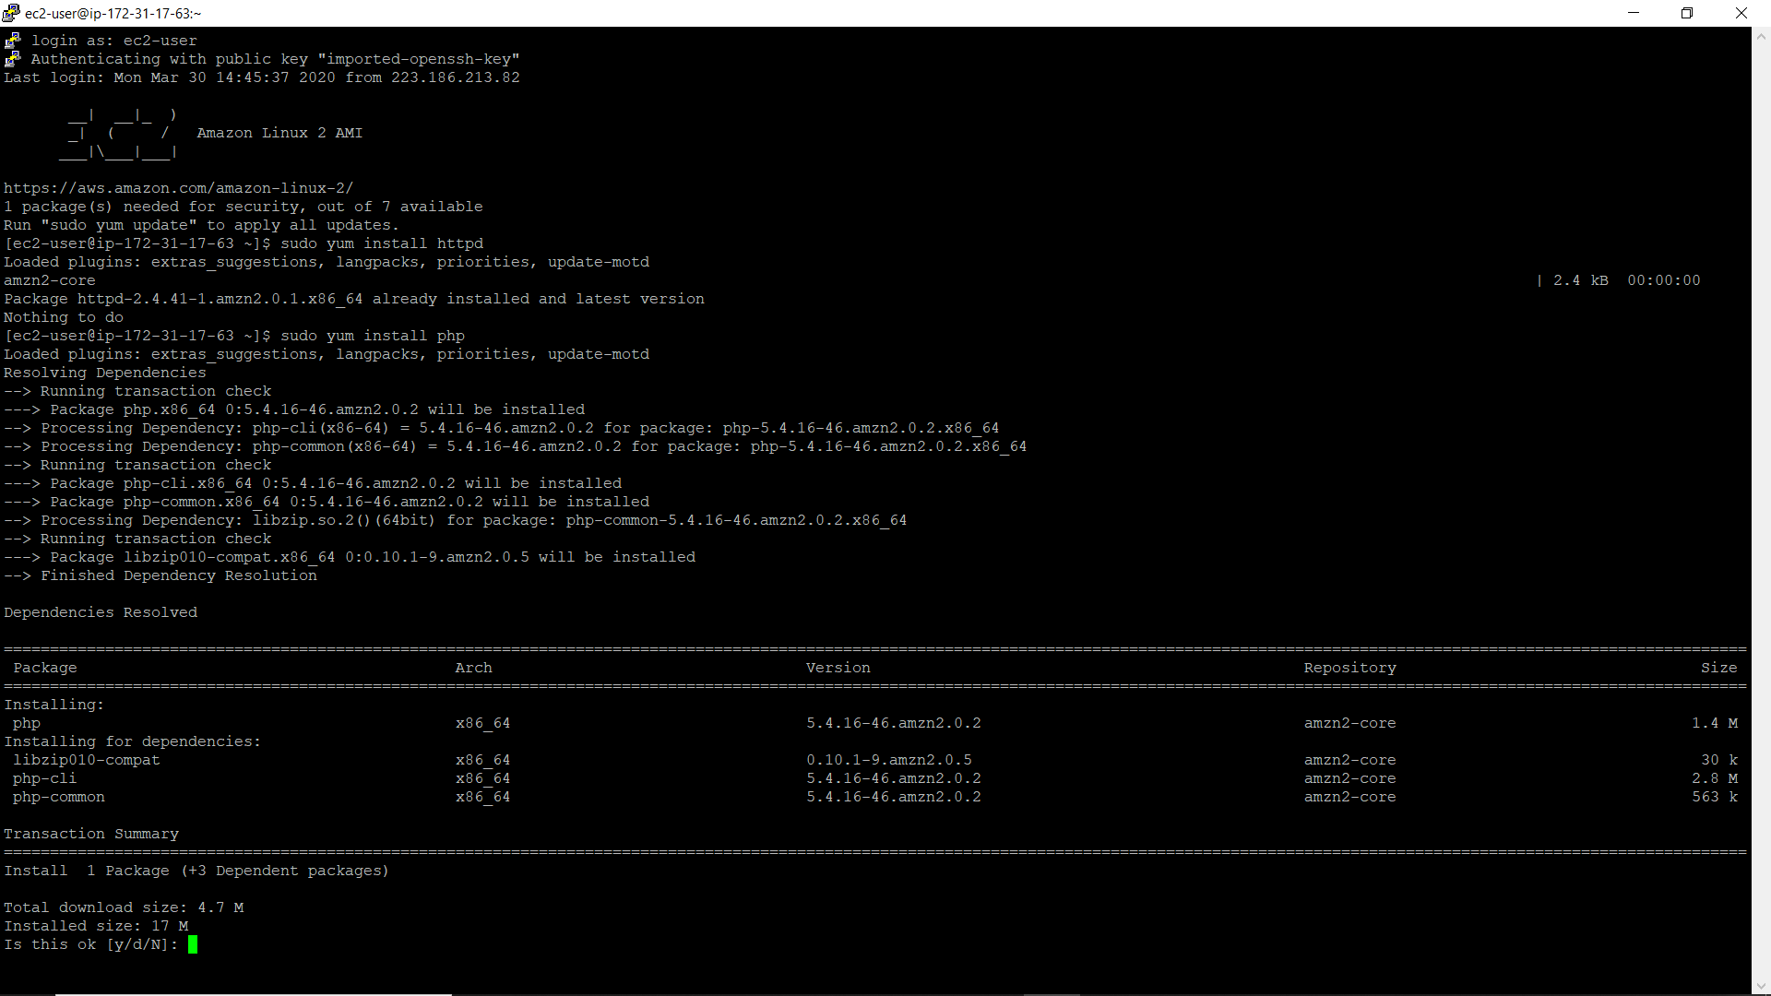

Snapshot 34

* Install package manager for php called composer using below command

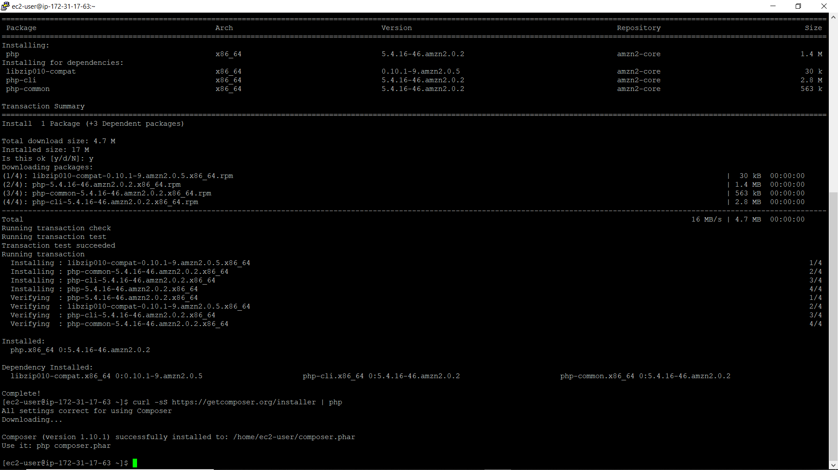curl -sS https://getcomposer.org/installer | php

Snapshot 35

* cd var/www/html – used for changing the directory

create a directory using the below command

sudo mkdir dir_name

* install AWS sdk (software development kit) using below command

sudo php -d memory_limit=-1 ~/composer.phar require aws/aws-sdk-php

In case if you get memory error -

sudo /bin/dd if=/dev/zero of=/var/swap.1 bs=1M count=1024

sudo /sbin/mkswap /var/swap.1

sudo /sbin/swapon /var/swap.1

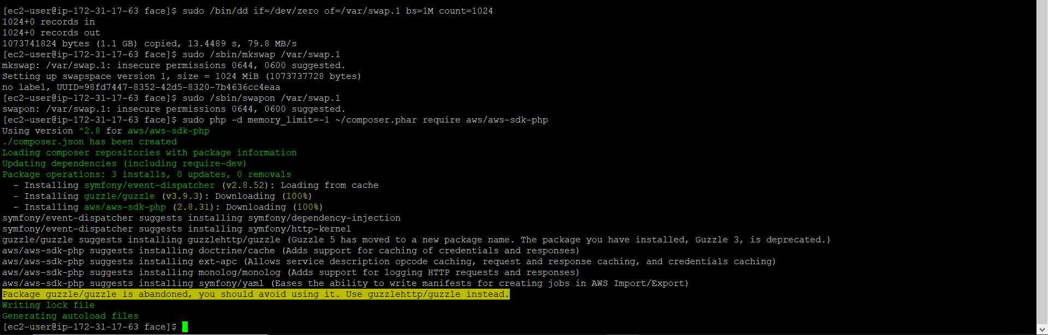

Snapshot 36

1. create IAM role

* open IAM management console

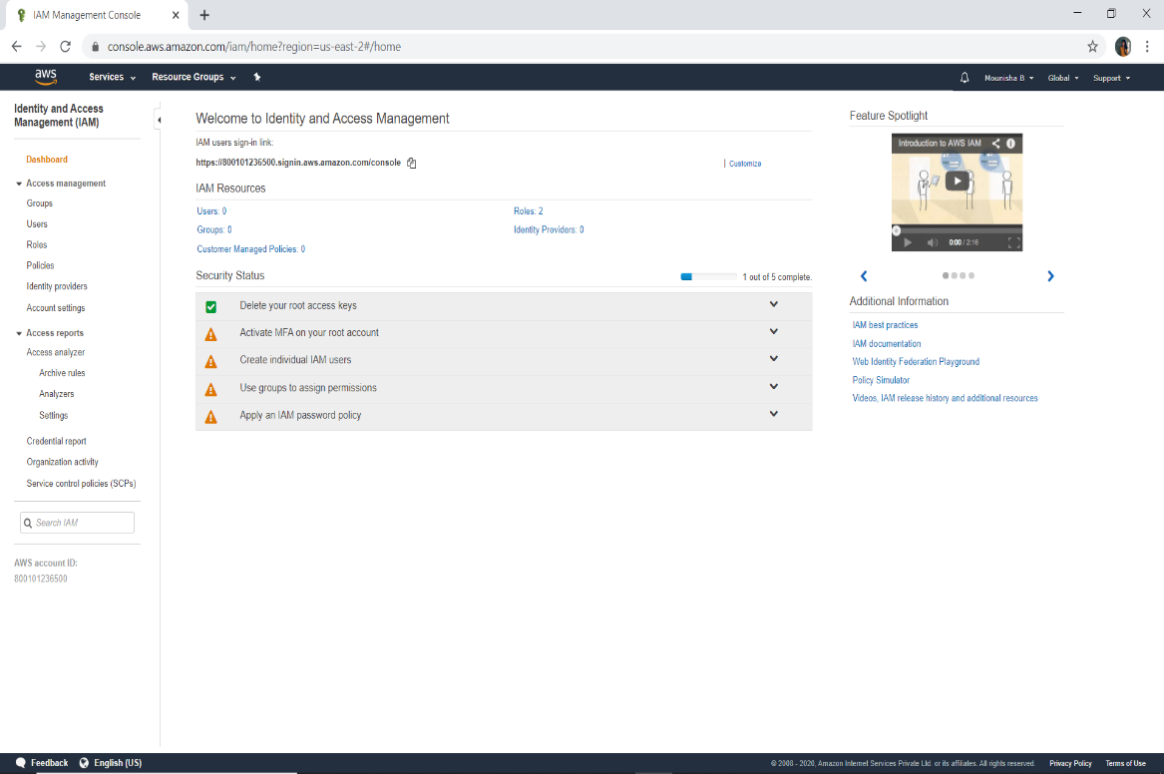

Snapshot 37

* Click on roles on the left hand side of IAM management console and click on create role
* Click on AWS service and select ec2 and go to next permissions
* Select the policies

1.AmazonS3FullAccess

2.AmazonRekognitionFullAccess

* Go to next: tags skip this and go to next: review

Type the role name and click on create role

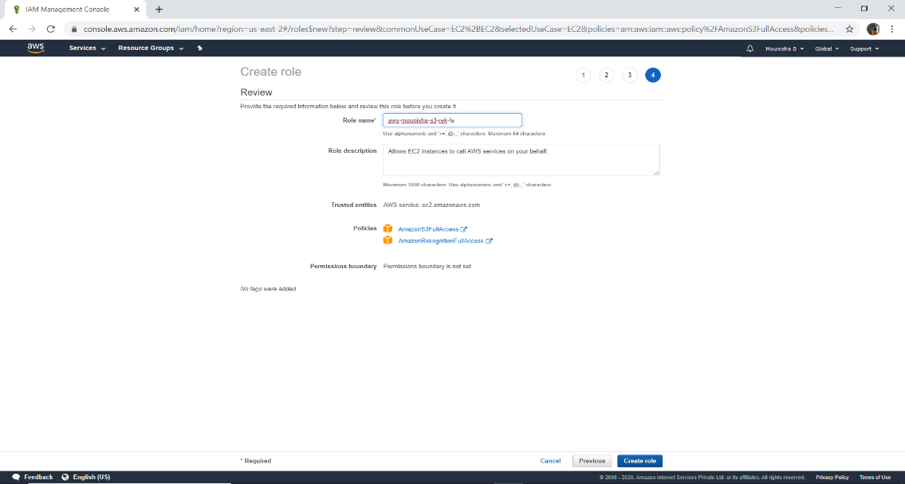

Snapshot 38

* Go back to ec2 console, click on action and click on instance settings and attach the iam role which you have created

1. Downloading and uploading the image

* copy the image URL from the google and go to putty and download the image using below command

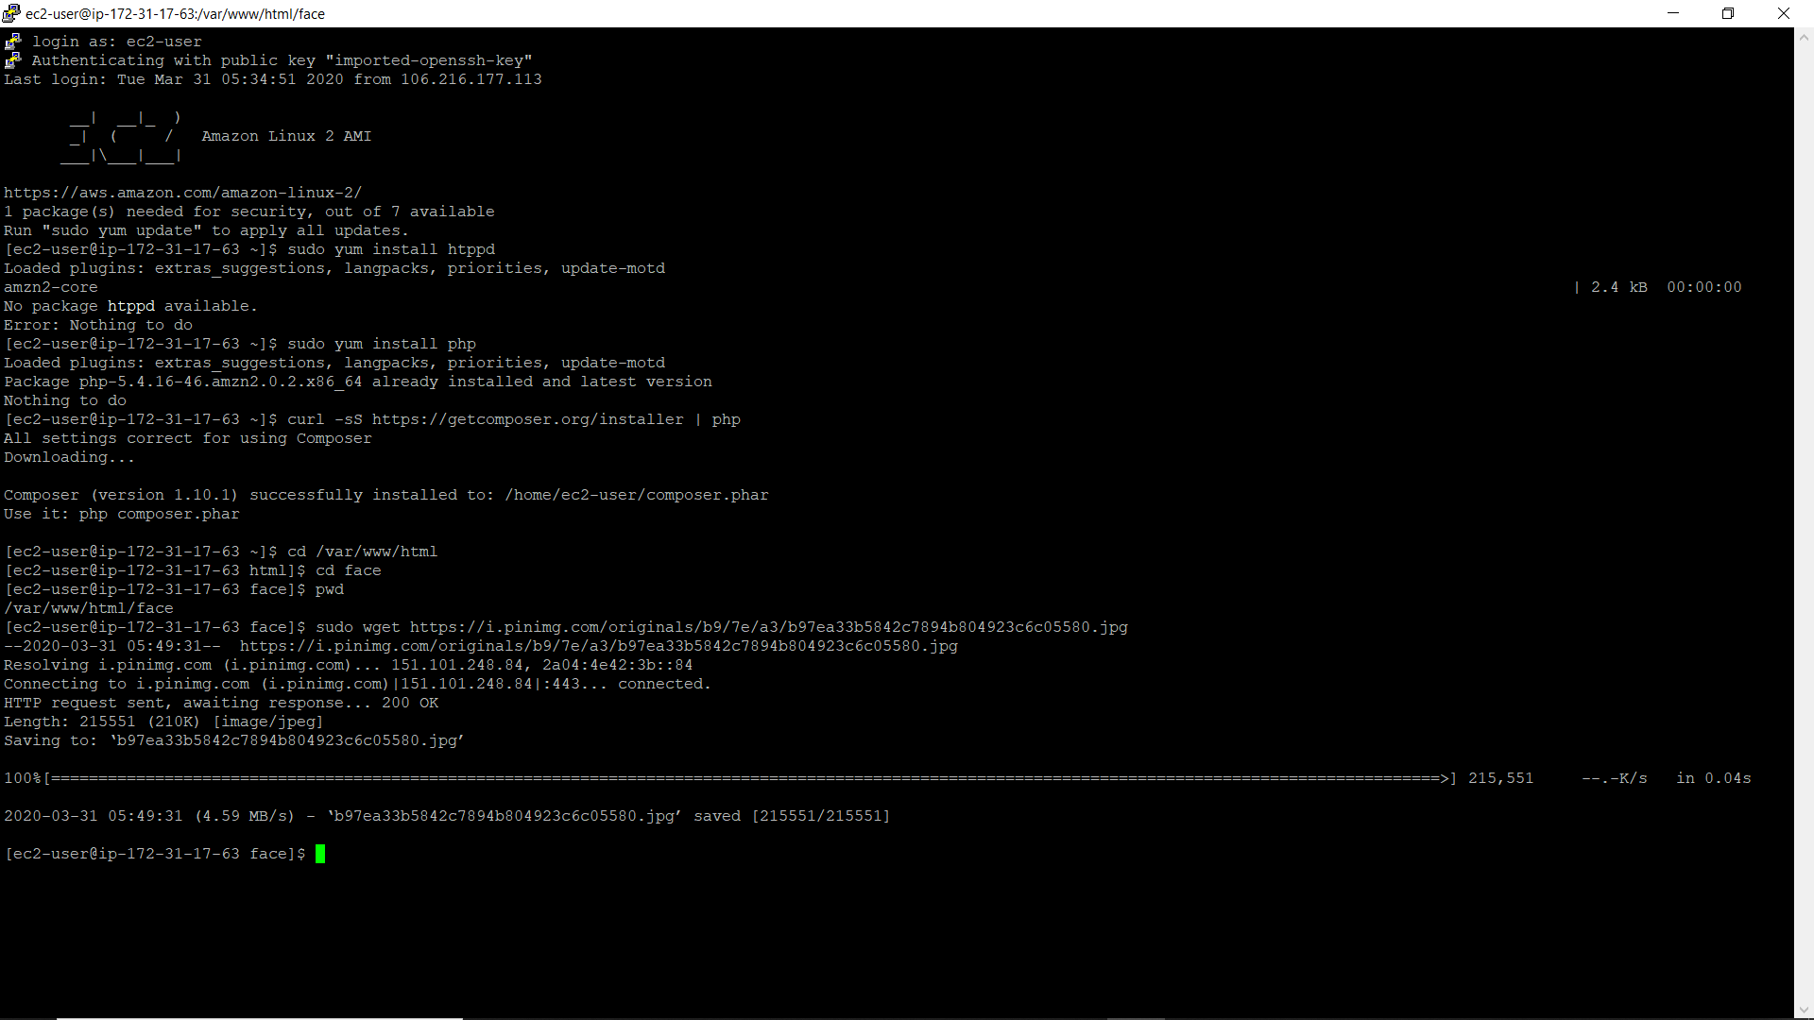sudo wget image_url

Snapshot 39

* use the below command to rename the file name

sudo mv old_filename new_filename

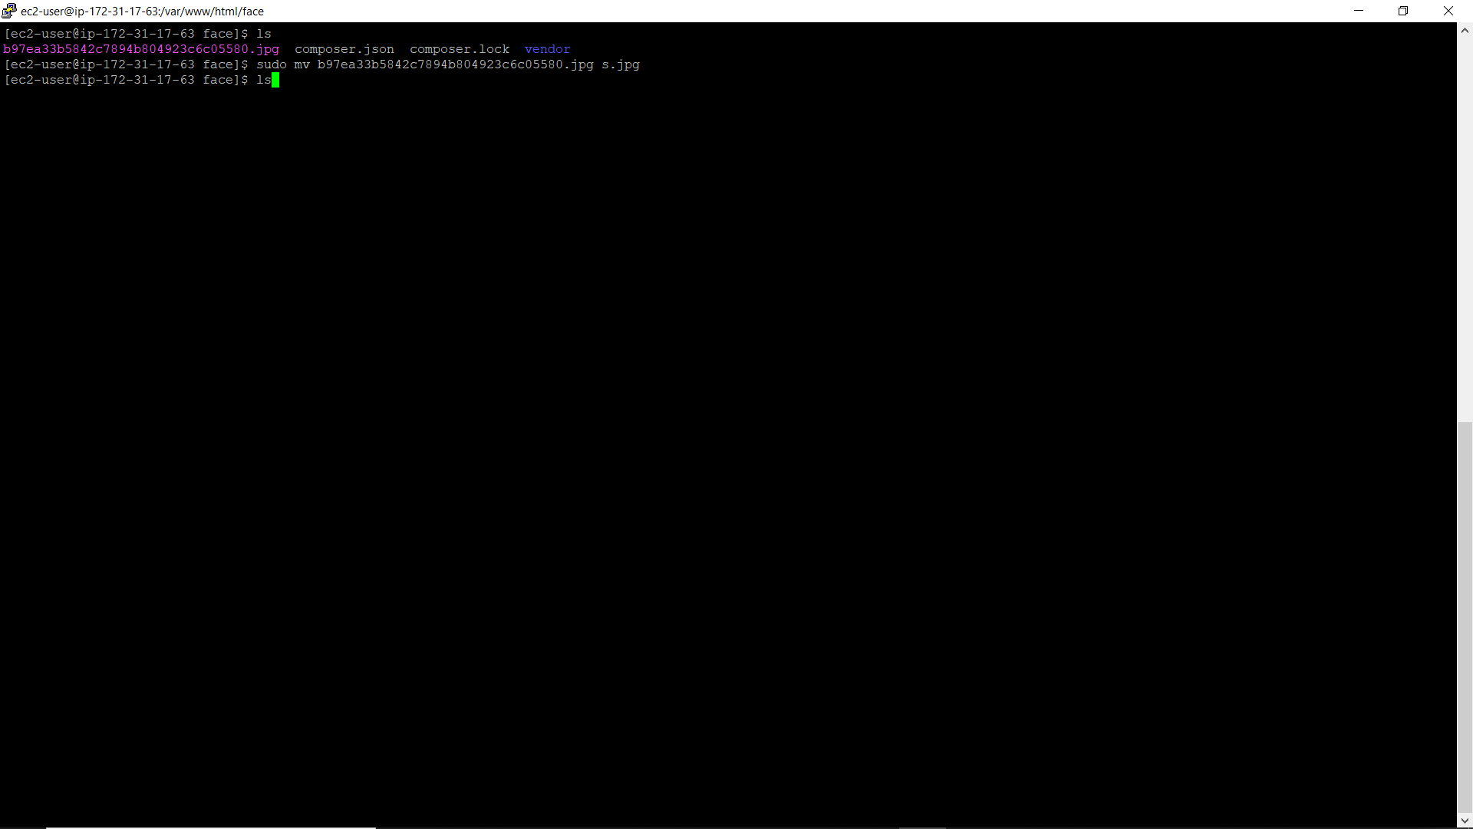

Snapshot 40

* now create a php file using the below command

sudo vim index.php

and write the code to upload the image into s3

Type :wq to save close the file

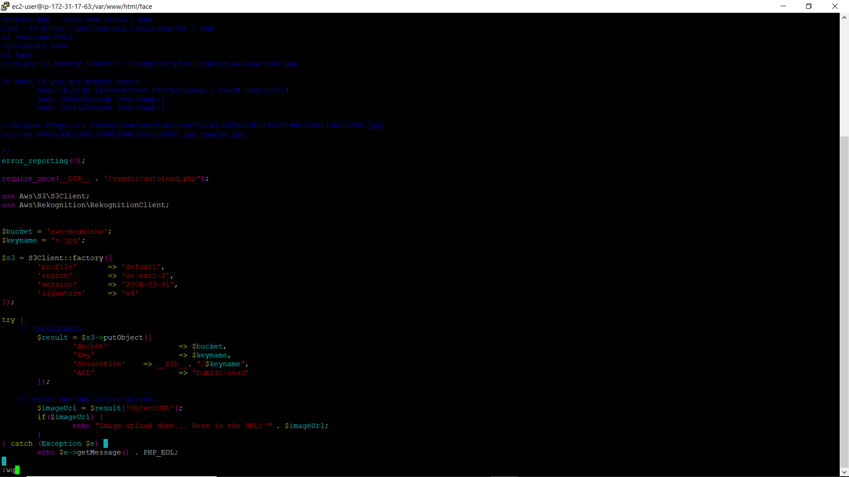

Snapshot 41

* run the php file using below command

sudo php index.php

after executing the command the message will be displayed saying that the image uploading is done

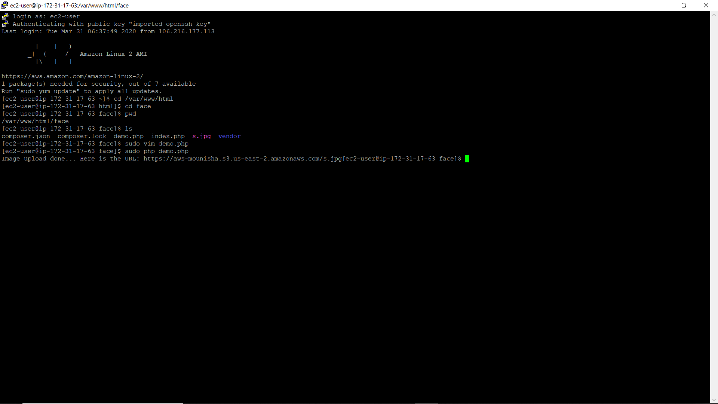

Snapshot 42

1. go back and check the s3 bucket to check whether the image has been uploaded to s3 bucket or not

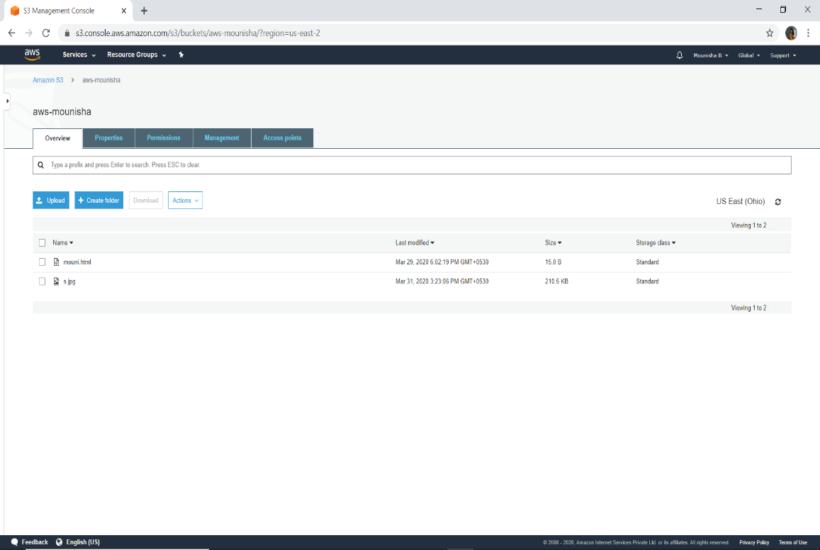

Snapshot 43

1. connecting ec2 to Rekognition

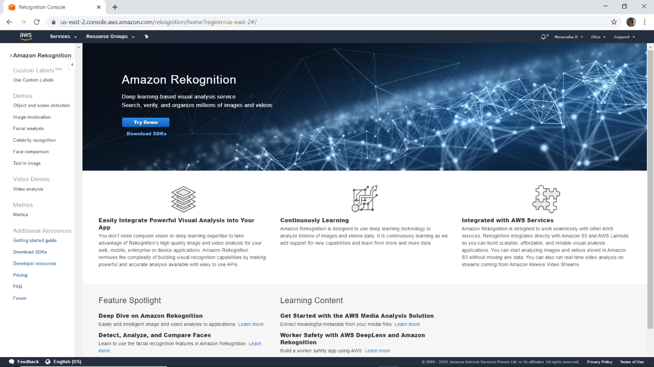

Snapshot 44

Services in Rekognition:

1. Text in image

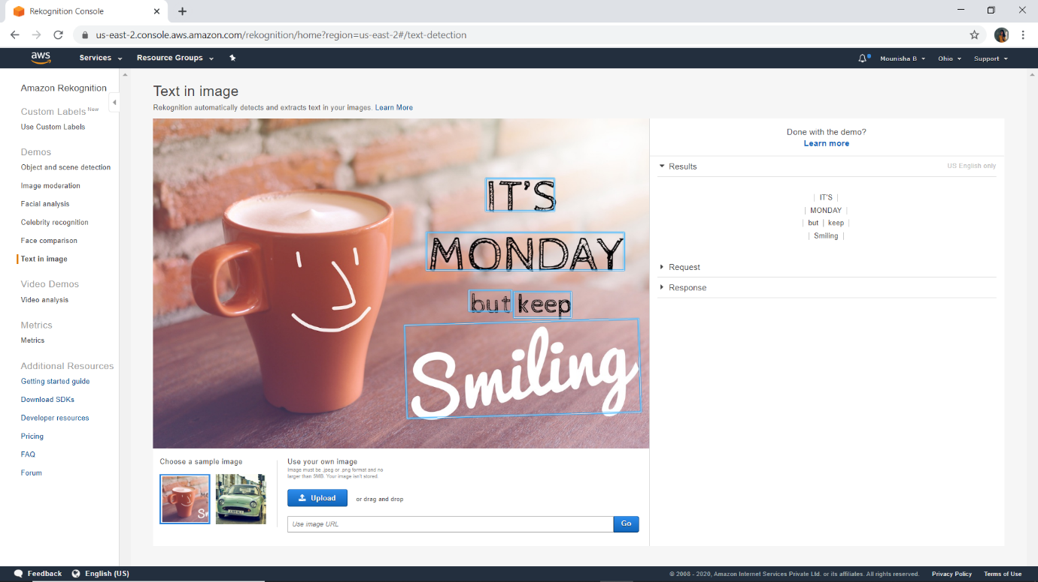

Snapshot 45

1. Celebrity Rekognition

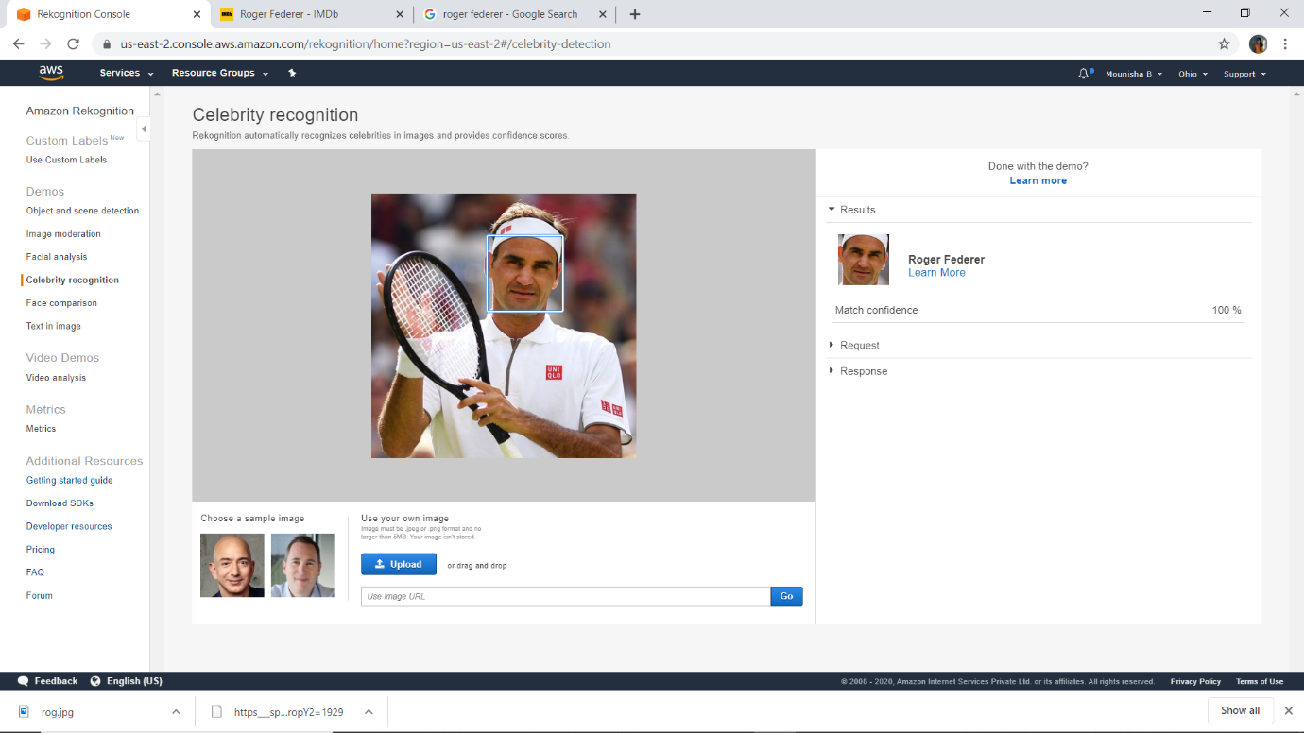

Snapshot 46

1. Facial analysis

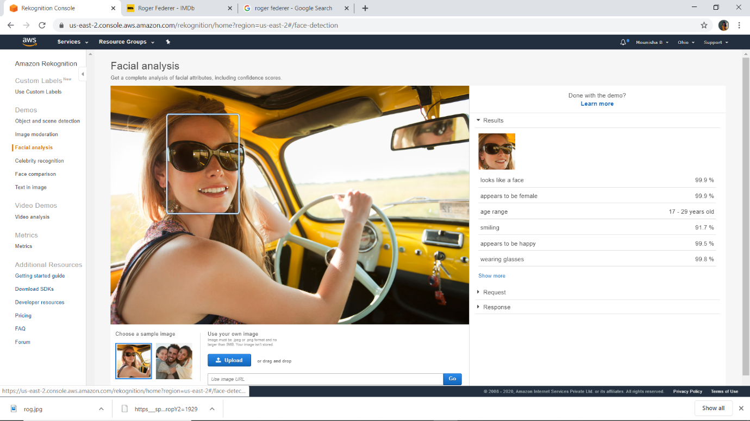

Snapshot 47

1. 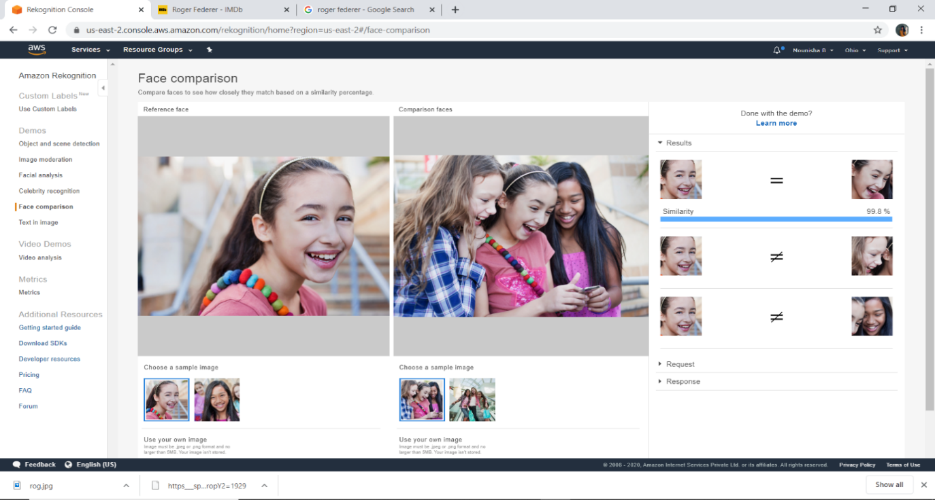Face comparison

Snapshot 48

1. Log in to putty by entering ip address and private key

* Enter into the directory where your previously created file exists
* Create the file using the command sudo vim index.php and write the code connect ec2 and Rekognition

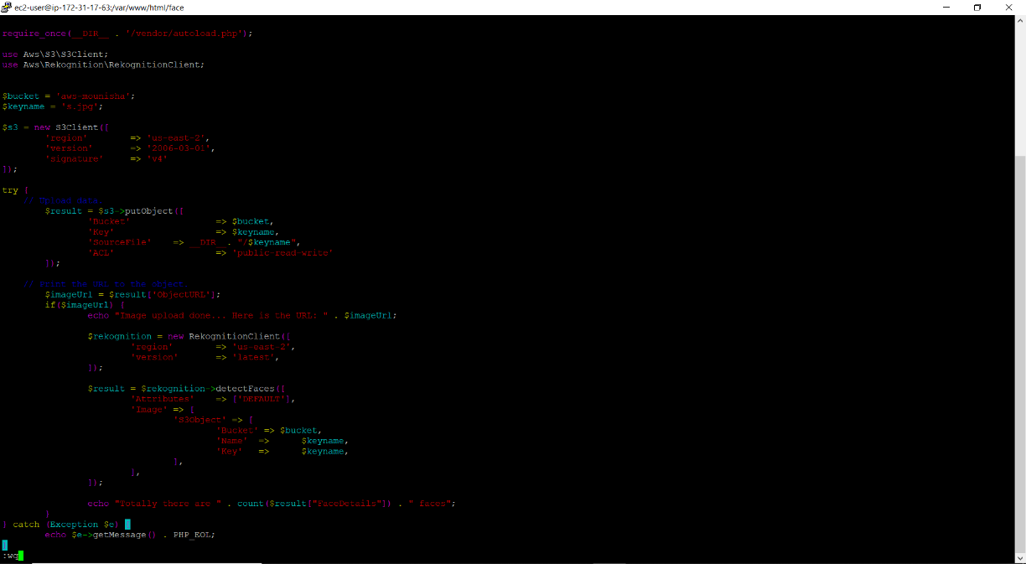 Type :wq to save and close the file

Snapshot 49

* 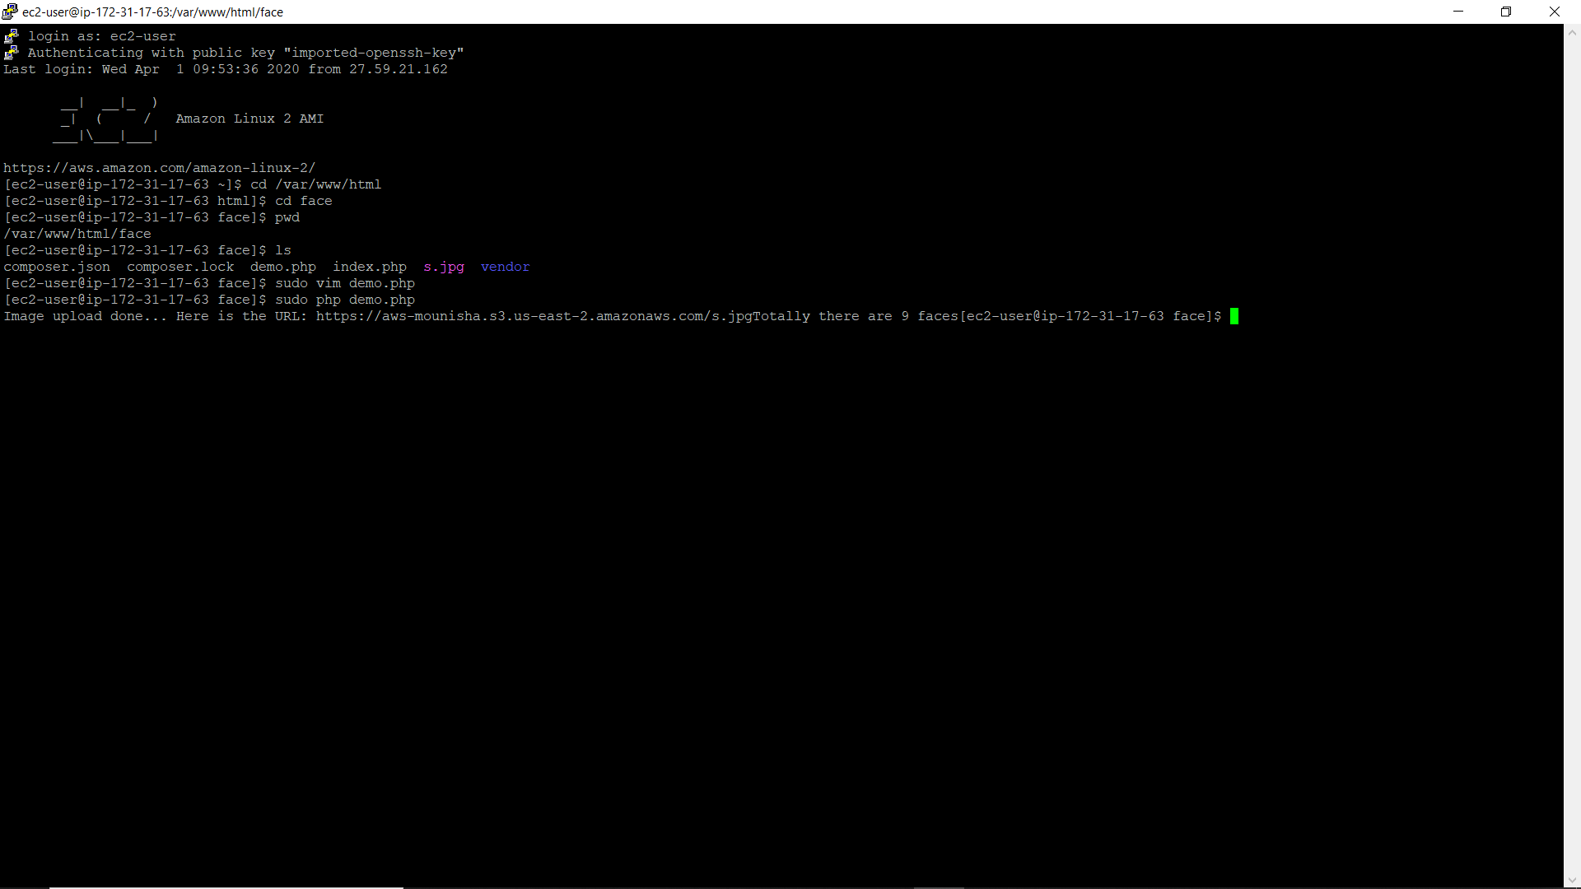Execute the file using the command sudo php index.php

Snapshot 50

1. Connecting ec2 to telegram web

There is a method called set webhook so we need to invoke this method from the telegram by using the below link

https://api.telegram.org/bot(mytoken)/setWebhook?url=https://mywebpagetorespondtobot/mymethod